**Seneca College**

**Assignment 3**

**Paul Seung Kyung Kim**

**Brendan Yawney**

**GAM537 Section NSA**

**George Kougioumtzoglou**

**December 11, 2020**

Contents

Introduction 3

Methods to Access Game 3

The Game 3

Controls 4

Functional Requirements – Assignment 1 5

Requirement: Two well-designed levels 5

Level - Dungeon 5

Level - Jungle 6

Requirement: 10 Objects 8

BP_Pickup 9

BP_Pickup_Shotgun 10

BP_Pickup_Thundergun 10

BP_Pickup_RocketLauncher 11

BP_Pickup_AssaultRifle 11

BP_Pickup_SniperRifle 12

BP_Pickup_GrenadeLauncher 12

BP_Pickup_Pistol 13

BP_Pickup_Railgun 13

BP_Pickup_Potion 14

Event Graph Example for all Pickups 14

BP_Launchpad 15

BP_Teleporter 16

BP_LevelTeleporter 17

Requirement: Pawn 19

BP_Player 19

Requirement: Environmental Lighting 21

Dungeon – Lighting 21

Jungle – Lighting 22

Requirement: Dynamic Lighting 23

Flashlight 23

Requirement: Terrain 24

Jungle 24

Forest 25

Functional Requirements – Assignment 2 26

Requirement: New Level 26

Requirement: Game Character 27

Requirement: UI & HUD 30

Requirement: NPC’s and Enemies 30

Requirement: Landscapes 34

Requirement: Lighting 35

Functional Requirements – Assignment 3 37

Requirement: Animated Character 37

Requirement: Fully animated NPC’s and Enemies 37

Requirement: Added AI Logic to Enemies/NPC’s 37

Requirement: Save & Load Functionality 37

Requirement: Intro Login Screen 37

# Introduction

This document describes our video game BOOM and how it meets the functional requirements for GAM537 Assignment #2.

## Methods to Access Game

New GitHub Repo: **https://github.com/paulkim26/gam537-assignment3** (invitation sent to your GitHub ID: docie80).

Please disregard the old repository that was used for assignment 1 + 2 (**https://github.com/paulkim26/gam537-fps**).

YouTube: <https://youtu.be/LougxpLUhcI>

## The Game



BOOM is a fast-paced arena first person shooter featuring both gothic horror and science fiction elements. The levels are set in distinct arenas where players must fend off hordes of enemies for as long as possible.

The game draws inspiration from classic PC first person shooter games including:

* Quake III Arena (1999)
* Unreal Tournament (1999)
* DOOM (1993)

### Controls

|  |  |
| --- | --- |
| **Input** | **Function** |
| Mouse | Aim |
| Left-click | Fire |
| W | Move forward |
| S | Move backward |
| A | Strafe left |
| D | Strafe right |
| F | Toggle flashlight |
| Space bar | Jump |

# Functional Requirements – Assignment 1

## Requirement: Two well-designed levels

**“Two well-designed levels (though you can create multiple levels).”**

Level - Dungeon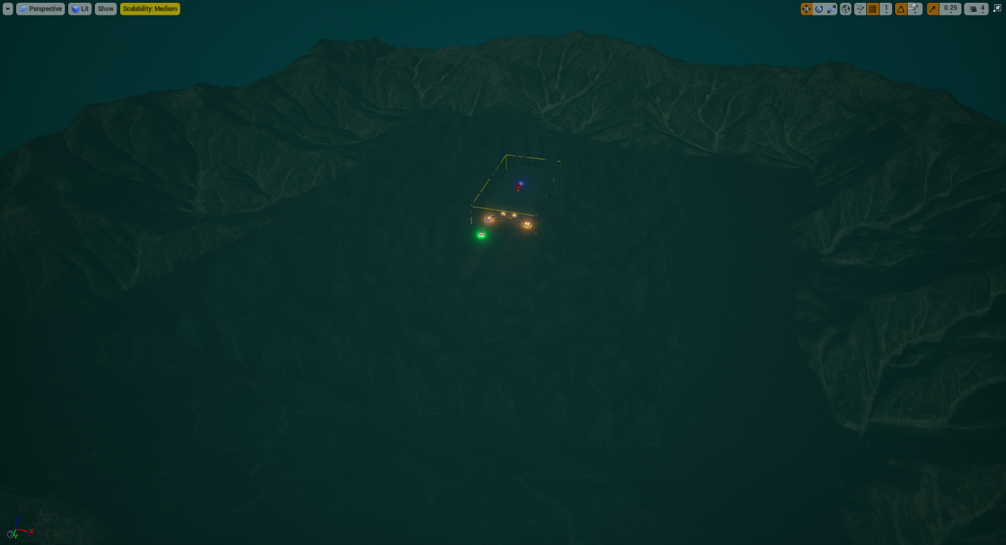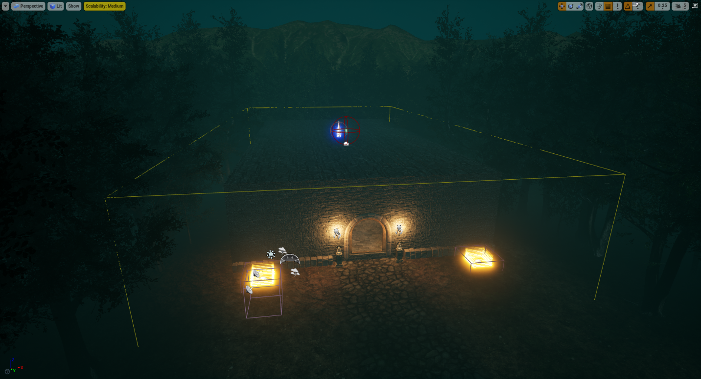

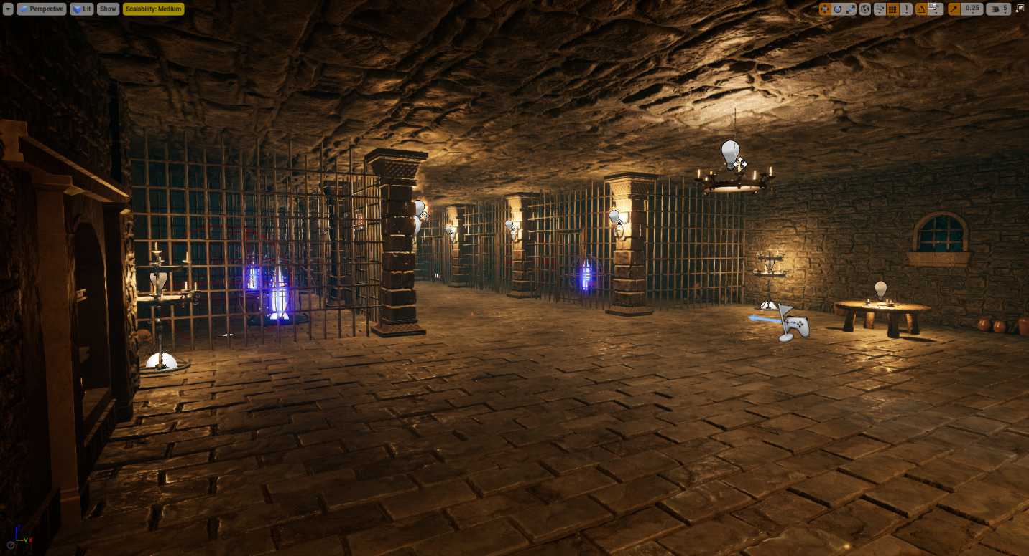

Level - Jungle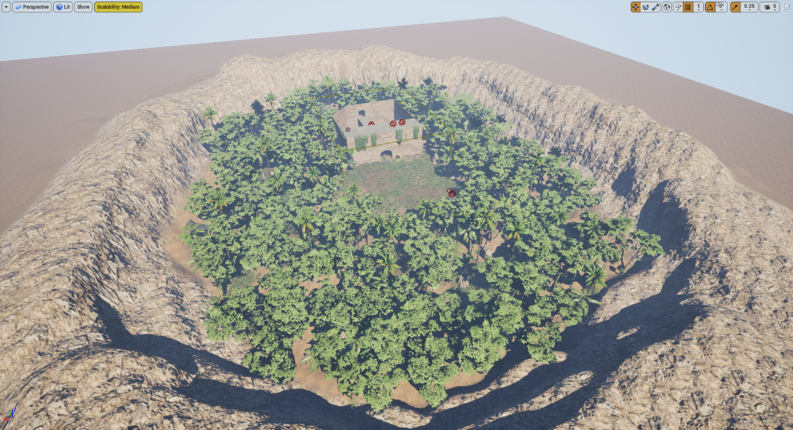

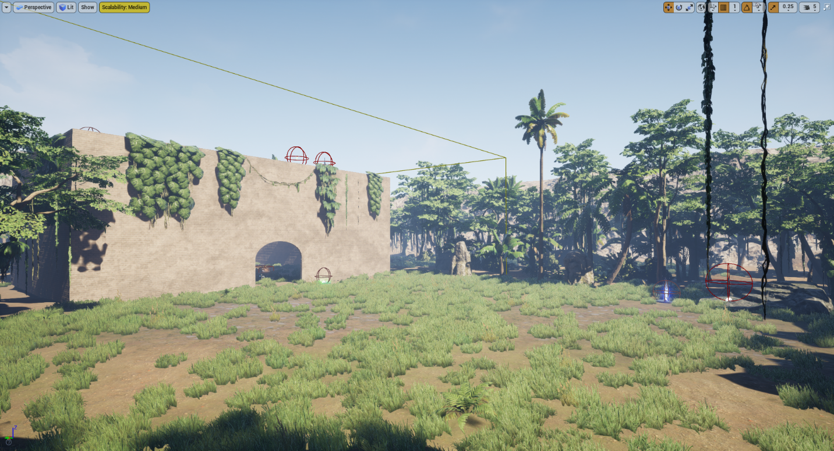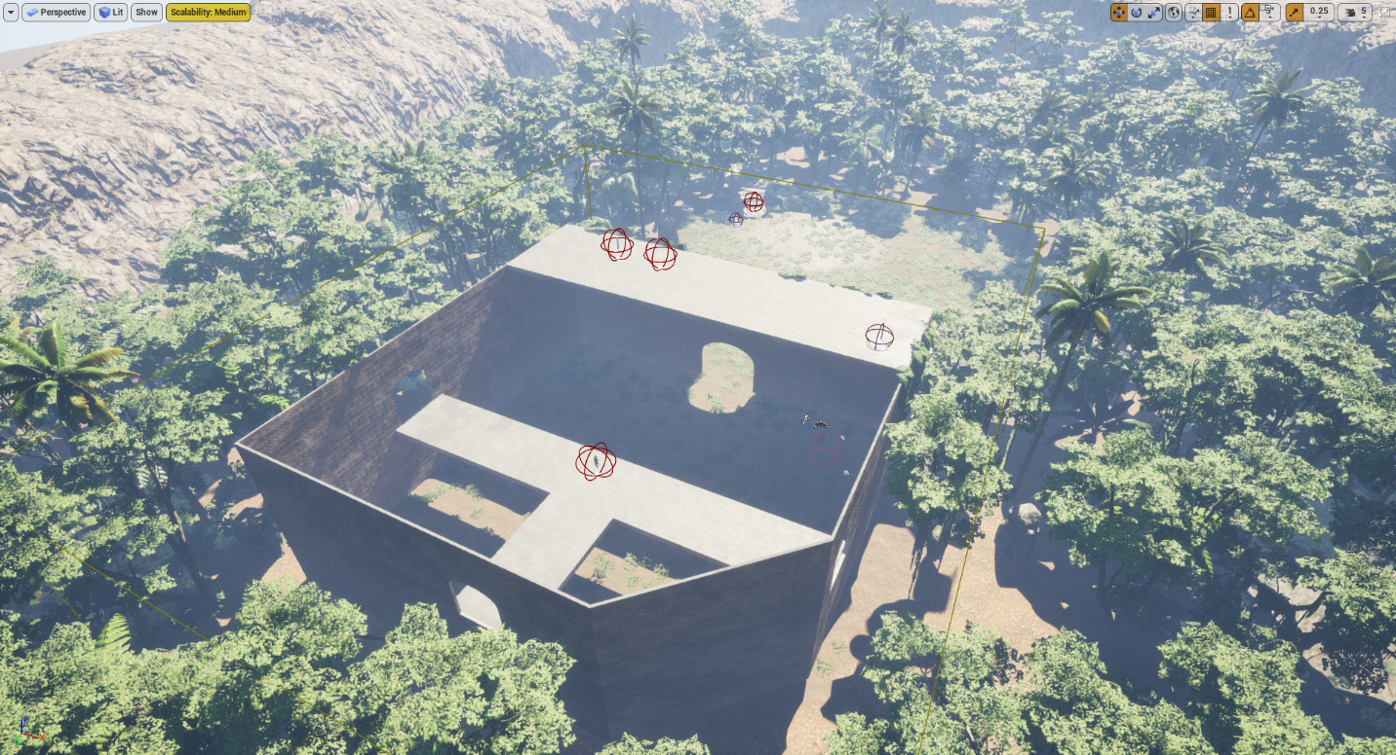

## Requirement: 10 Objects

**“A number of 10 objects designed in the Editor or designed in any other application or imported by any source. The objects should be blueprints with basic colliders and some functionality (your call).”**

Most of our objects come in the form of pickups that the player can collect around the 2 levels. Each pickup is derived from the same BP_Pickup class and thus share similar blueprints. The game also includes teleporters and launchpads with unique blueprints (note: some blueprints left out for the sake of simplicity).

### BP_Pickup

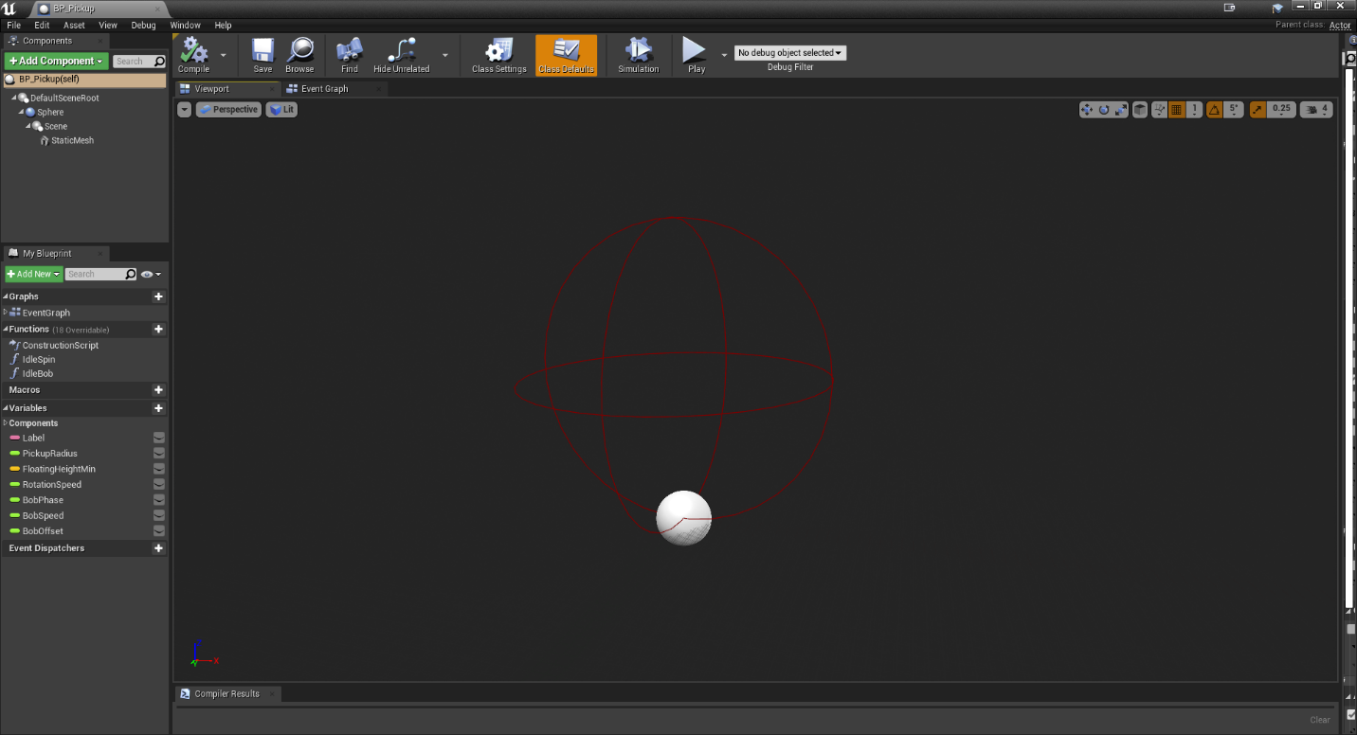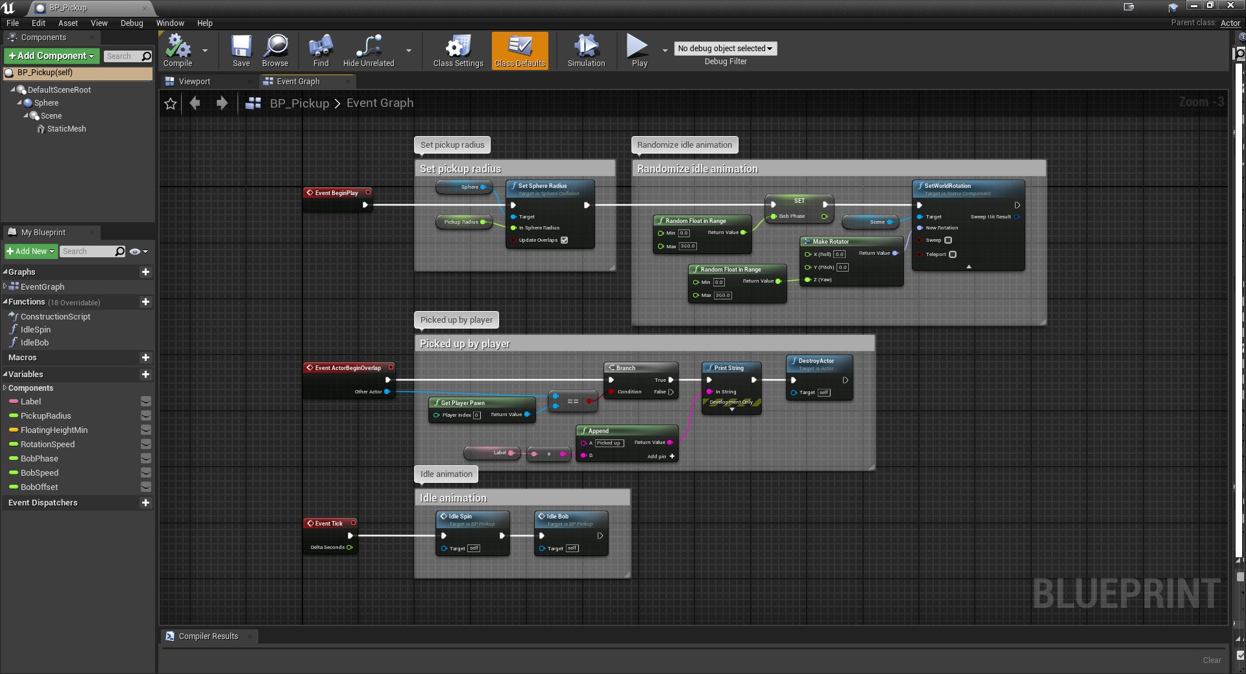

### BP_Pickup_Shotgun

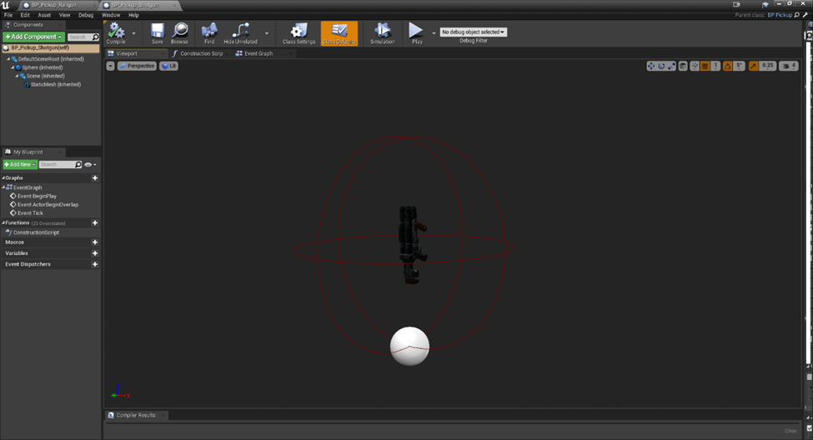

BP_Pickup_Thundergun 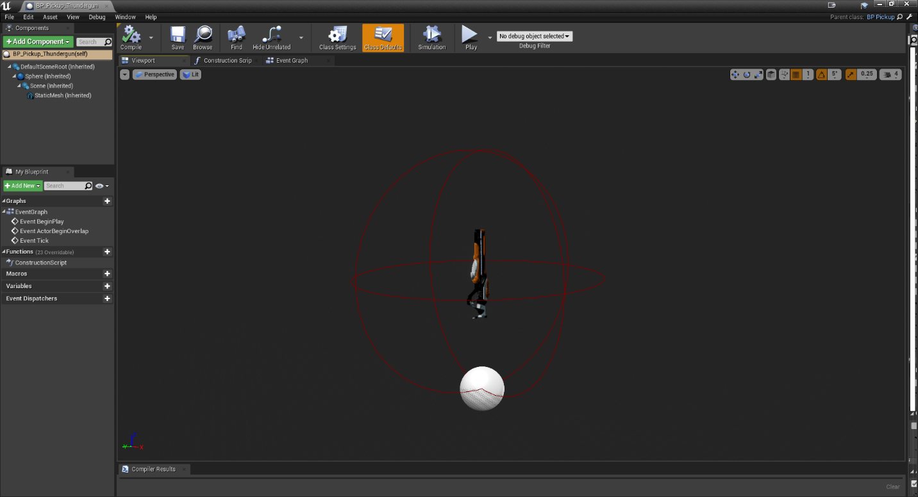

BP_Pickup_RocketLauncher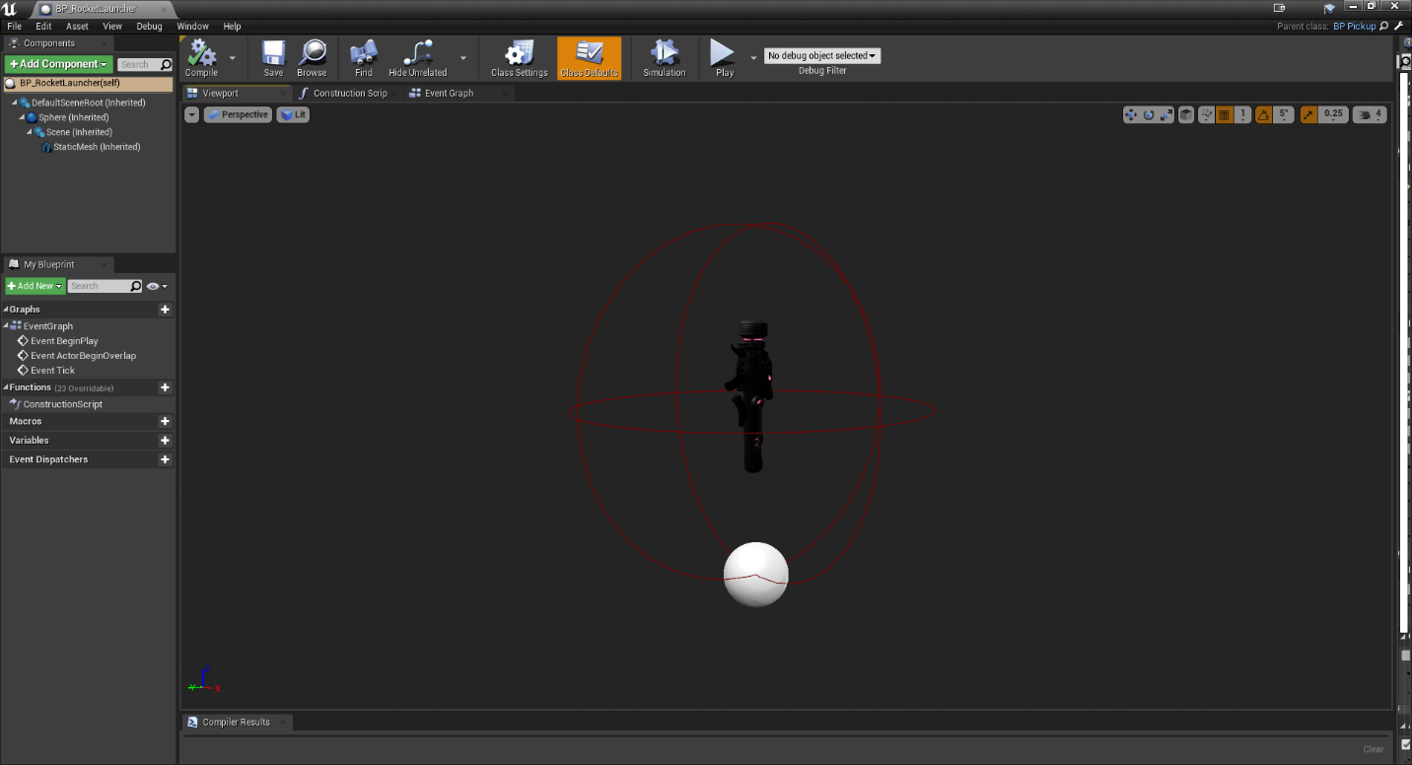

BP_Pickup_AssaultRifle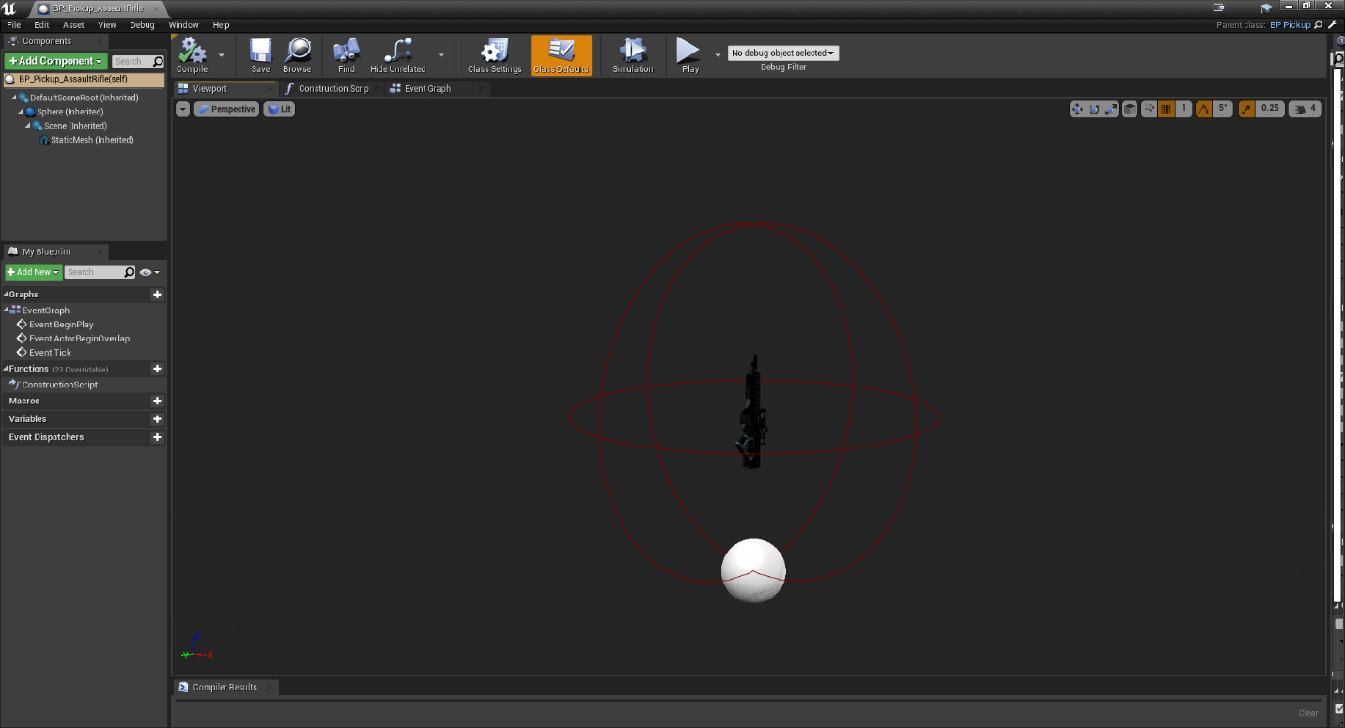

BP_Pickup_SniperRifle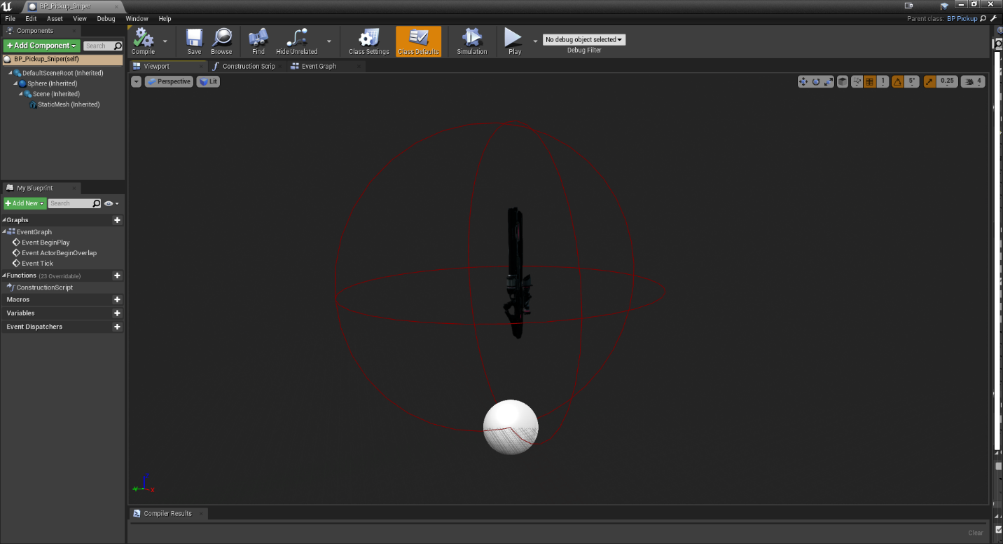

BP_Pickup_GrenadeLauncher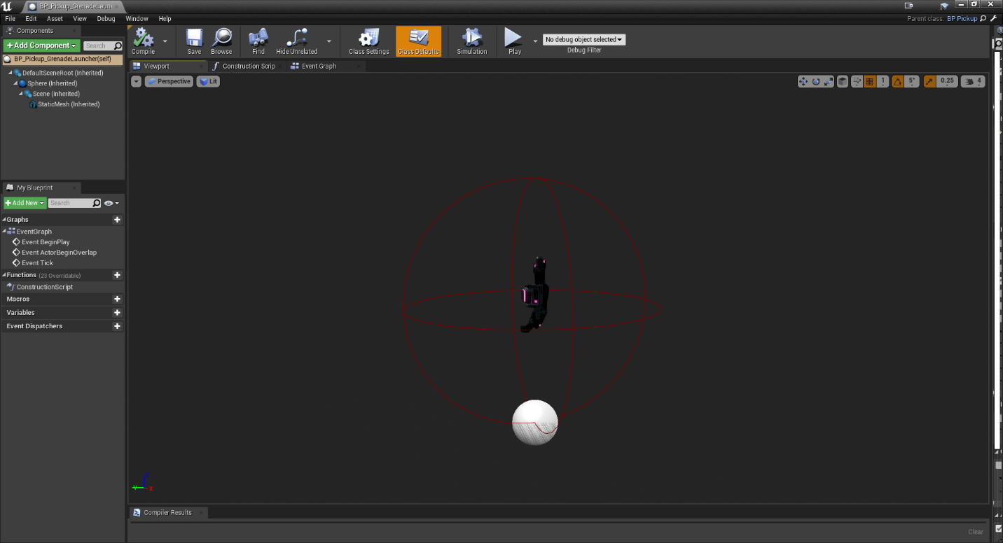

BP_Pickup_Pistol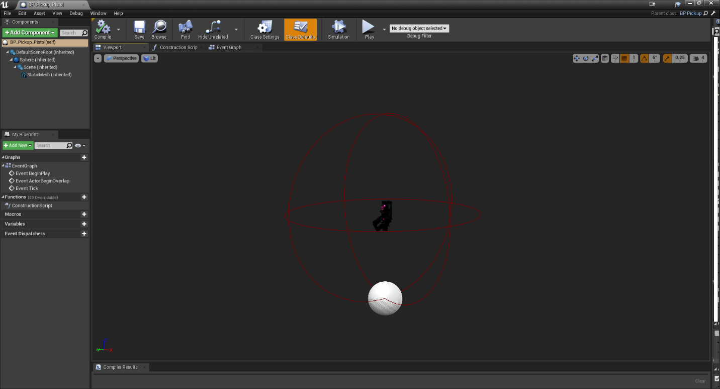

BP_Pickup_Railgun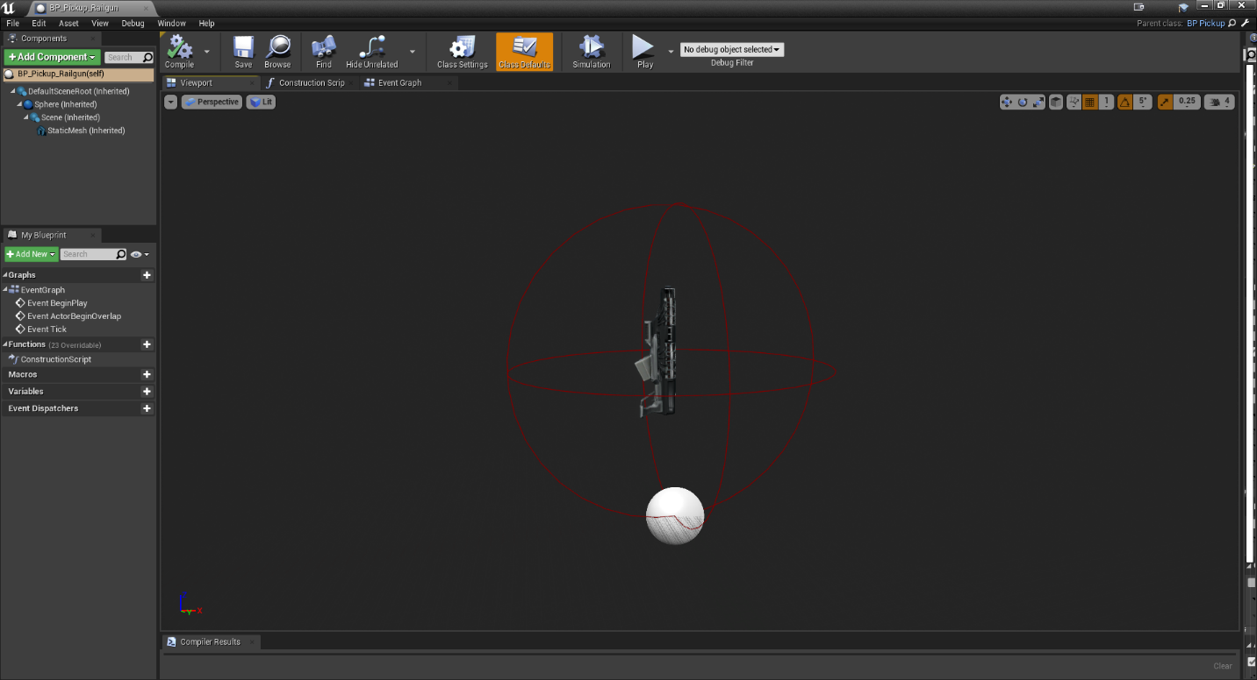

BP_Pickup_Potion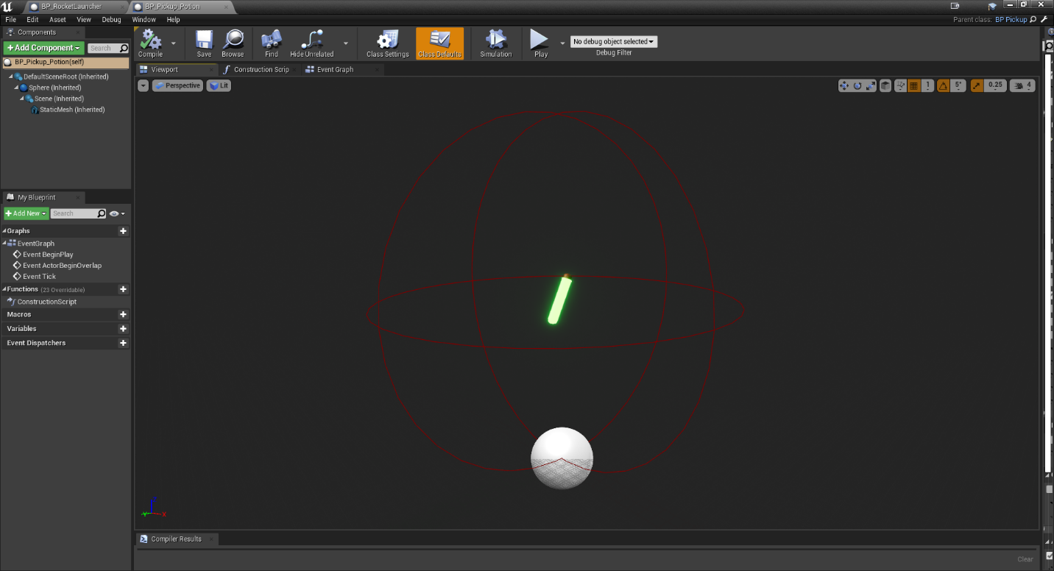

Event Graph Example for all Pickups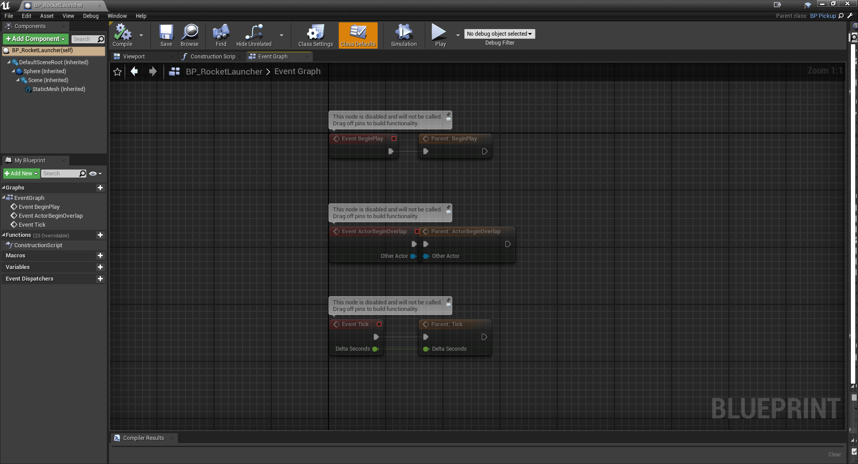

BP_Launchpad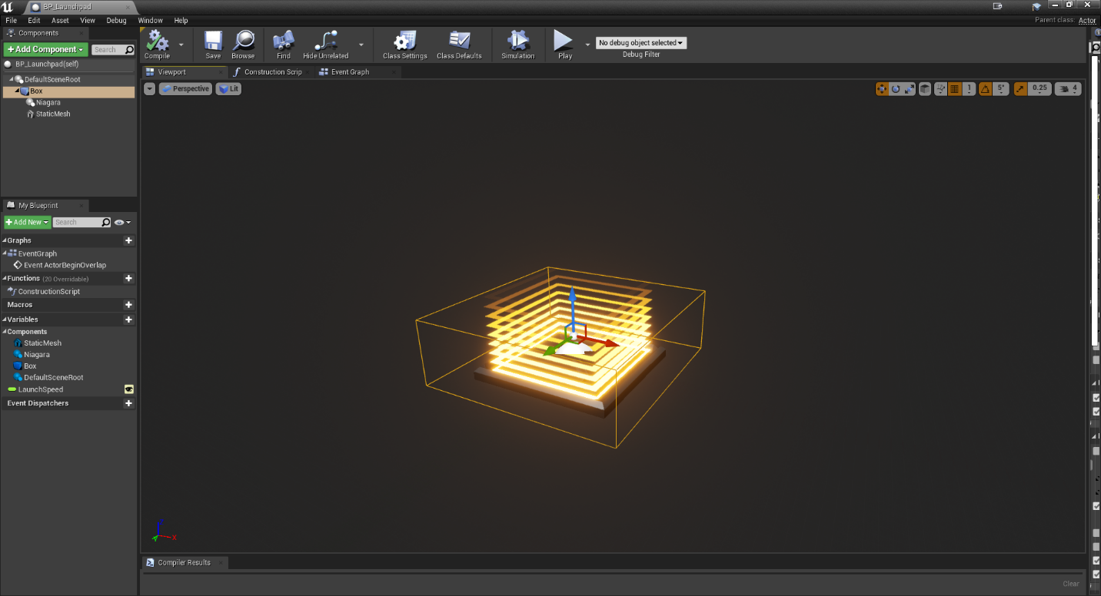

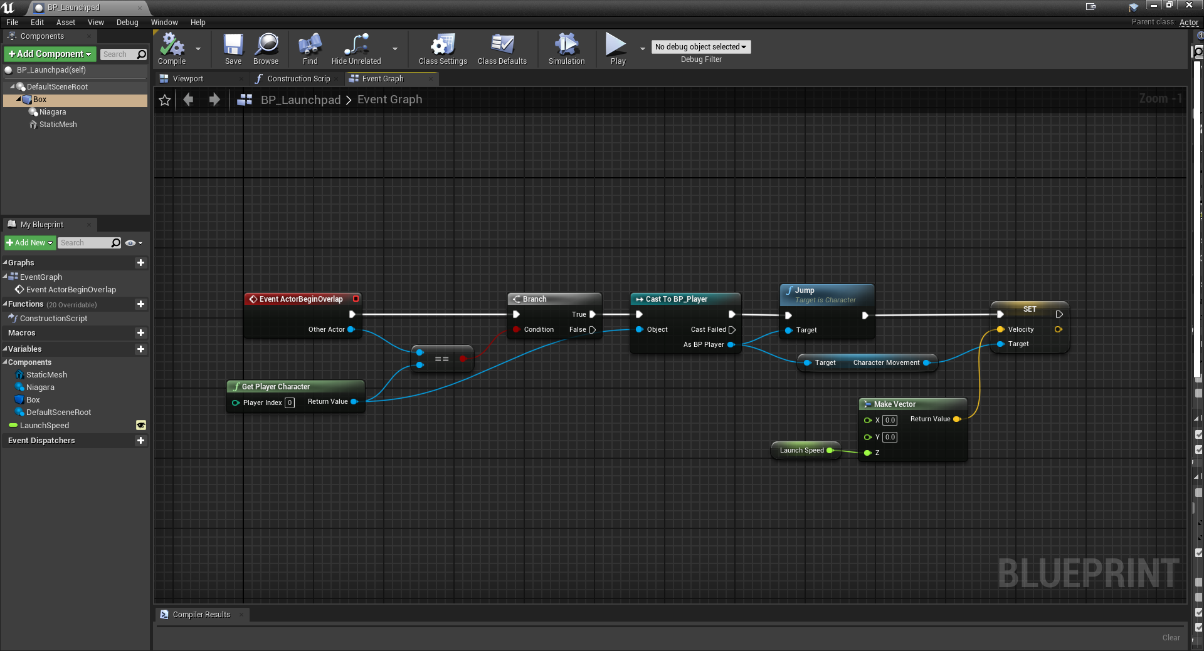

BP_Teleporter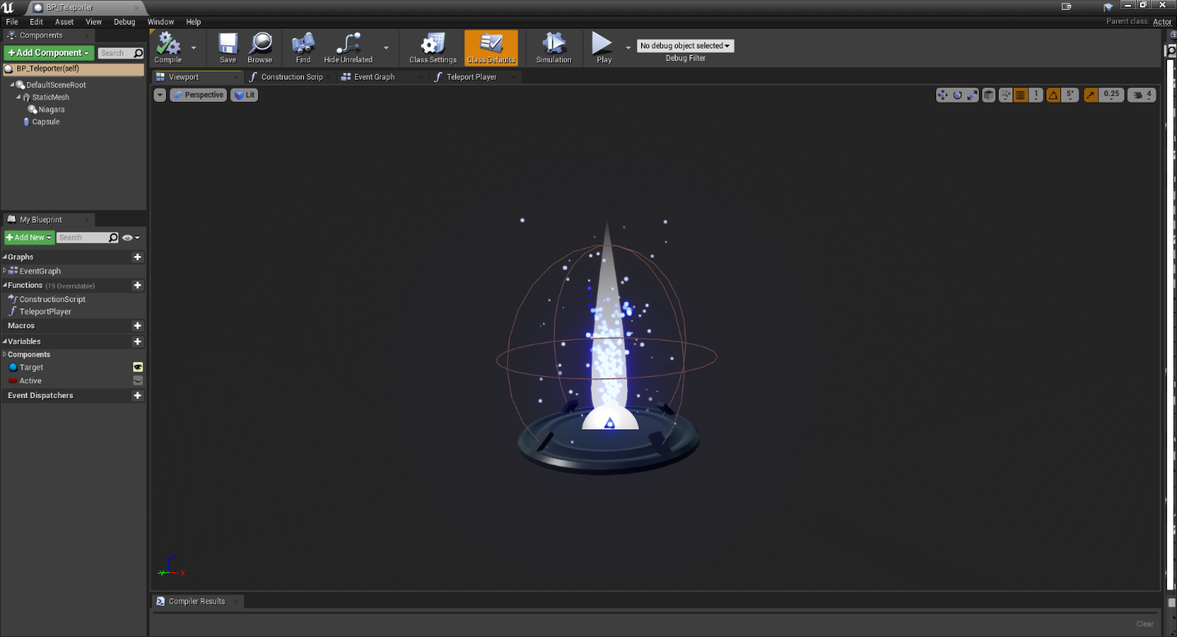

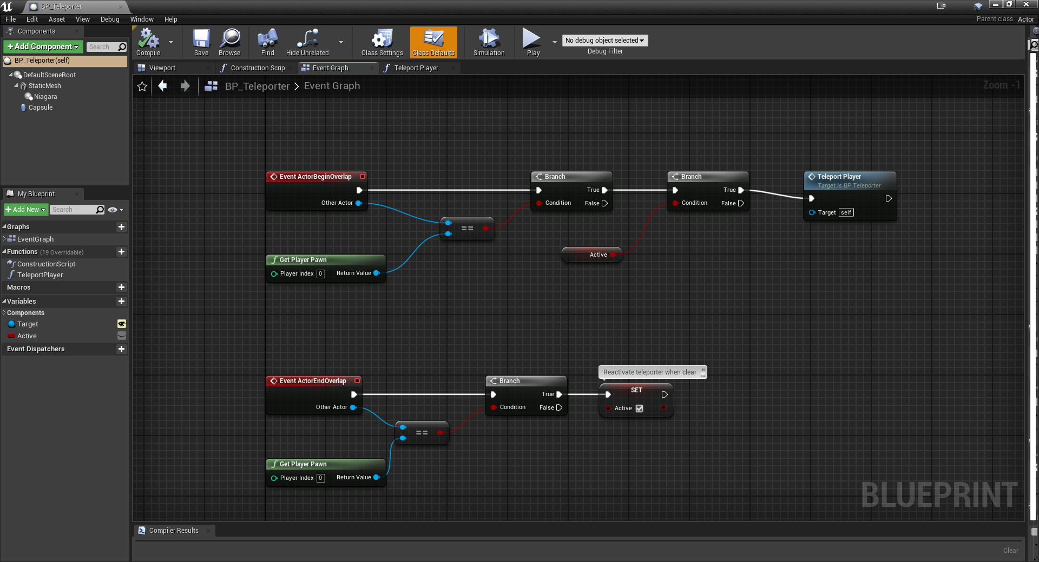

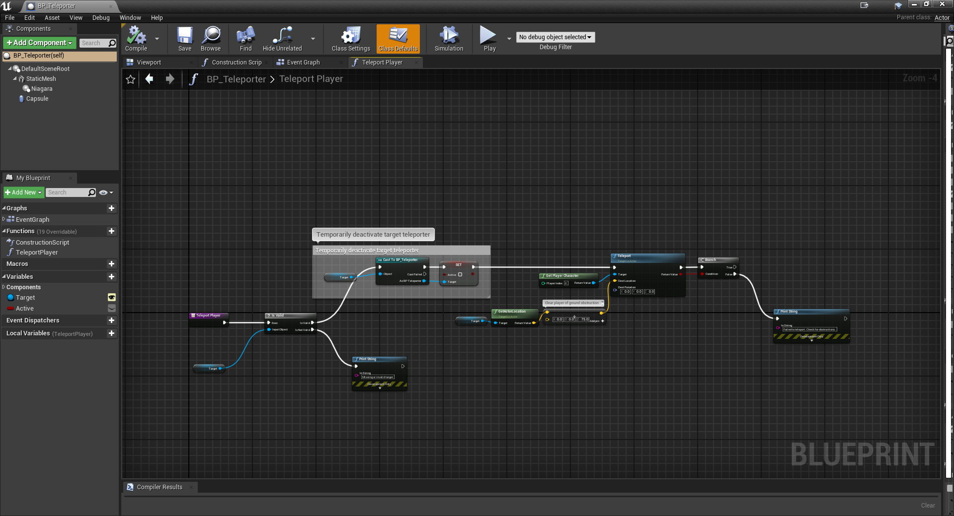

BP_LevelTeleporter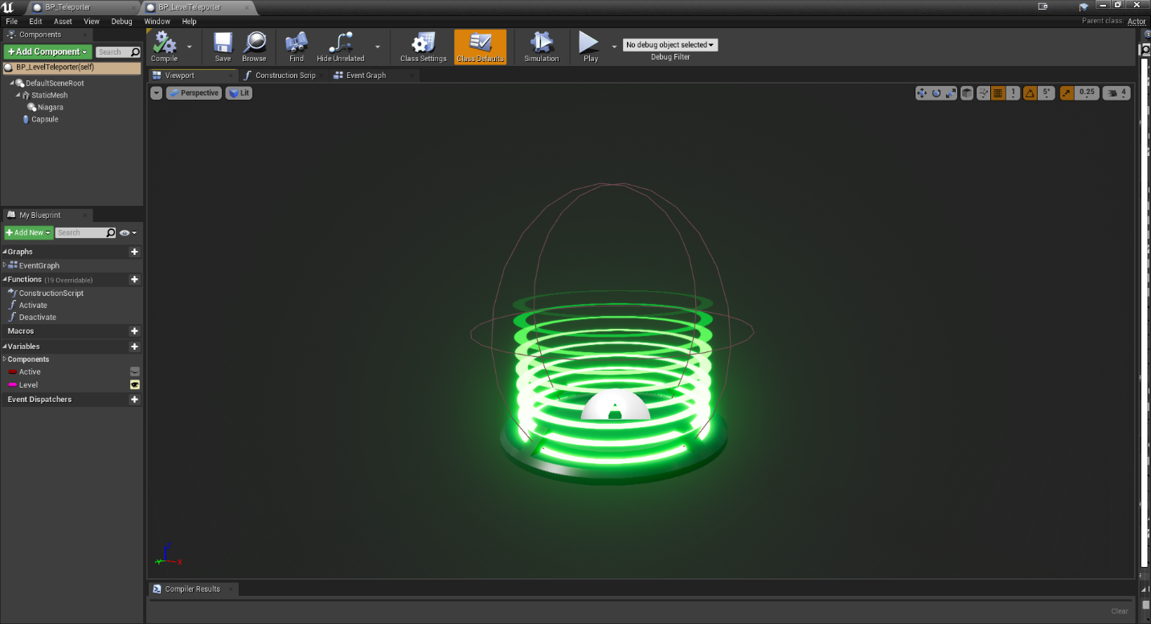

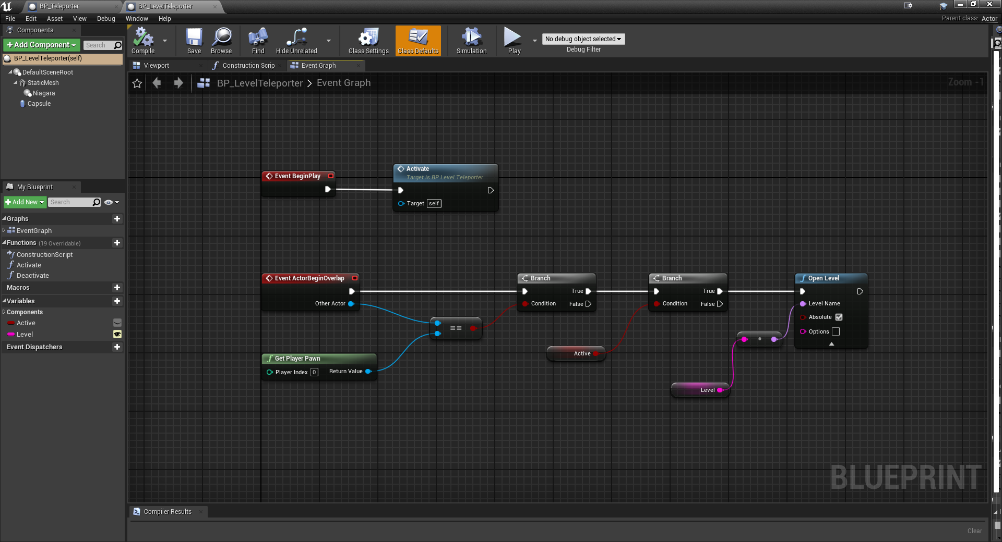

## Requirement: Pawn

**“A Pawn Character with fully working keys using Key Binding, camera and colliders.”**

Our game takes place from a first-person perspective, so the player character is merely a camera, mesh and a collider without an actual model. The player has a full range of movement and can use the F key to toggle their flashlight.

### BP_Player

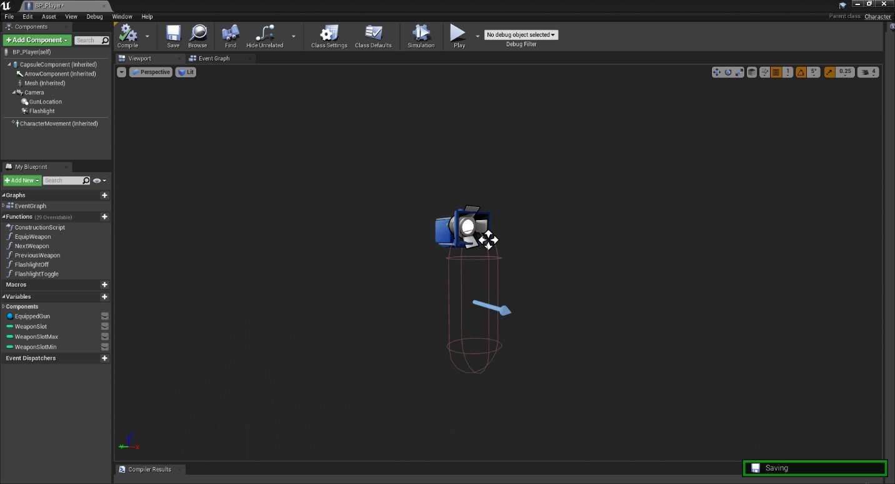

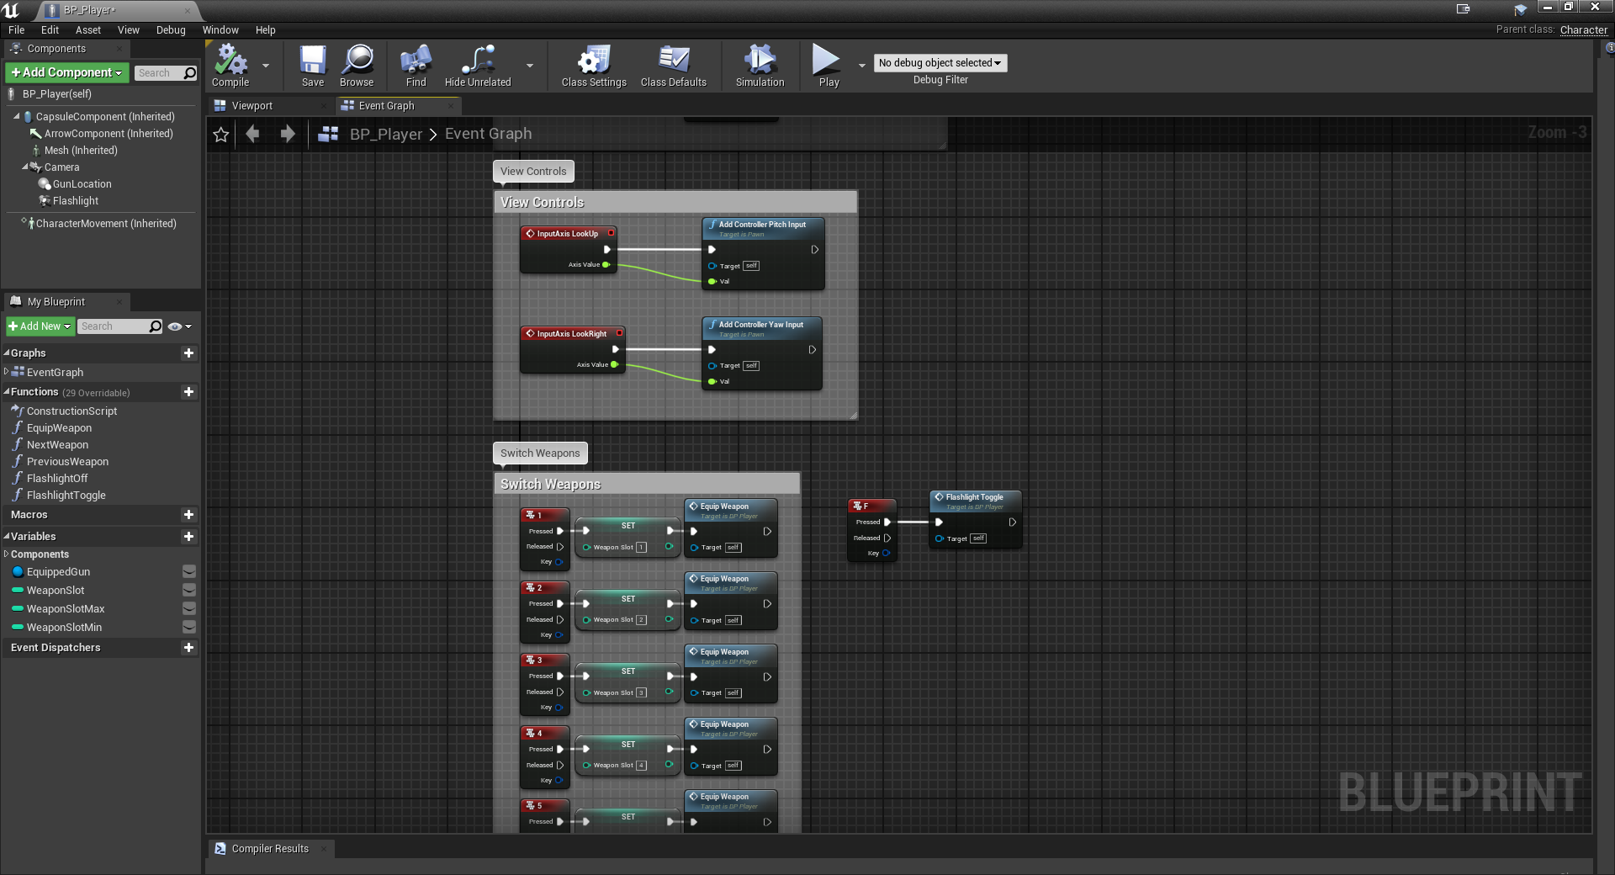

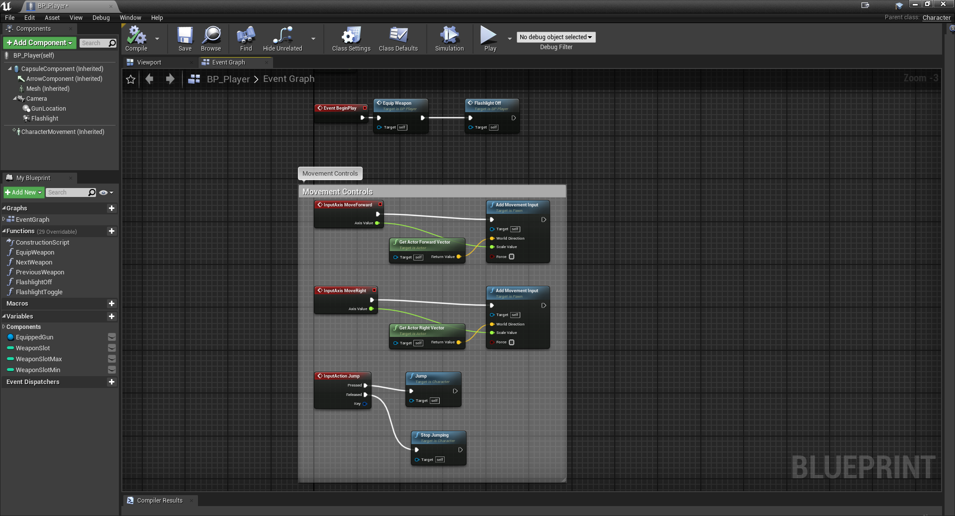

## Requirement: Environmental Lighting

**“Fully implemented lighting that includes at least a skydome, a directional light, and a number of other lights (a exception could be an internal – underground world, where the skydome – directional requirements are dropped).”**

Our game includes a sky sphere, directional light, exponential height fog, post processing volumes sky lights, and point lights to help light the scene and set the atmosphere.

### Dungeon – Lighting

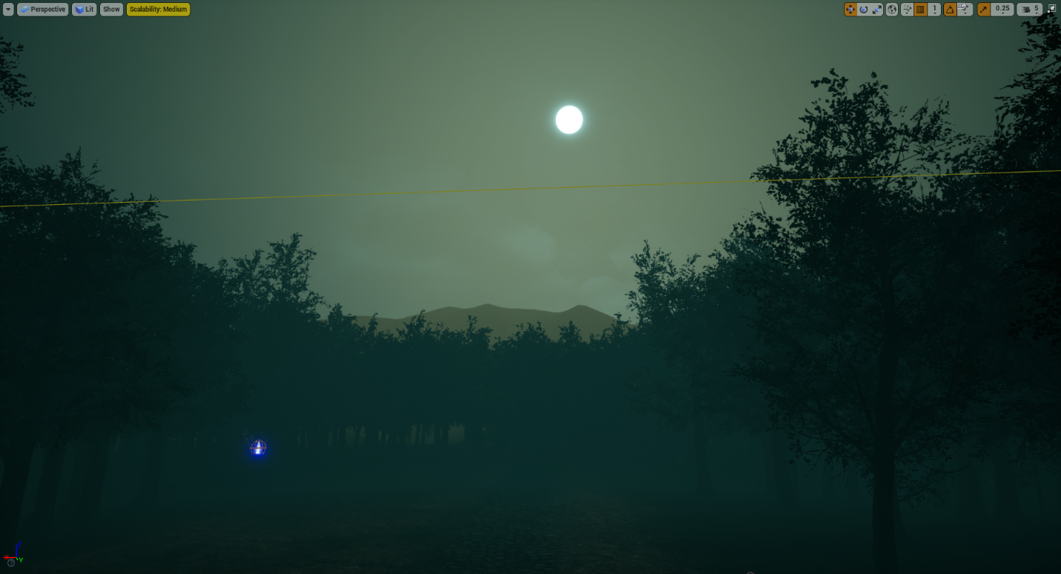



Jungle – Lighting 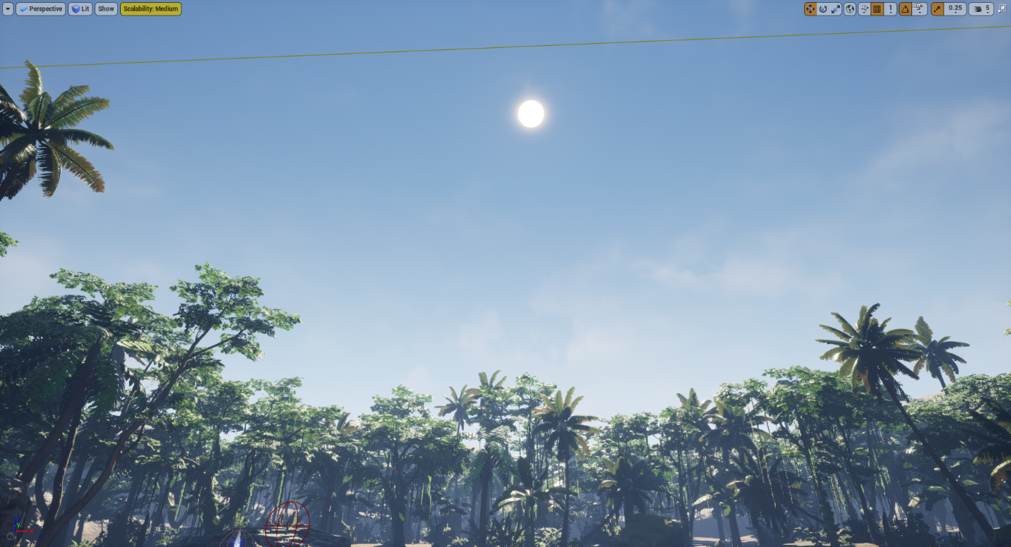

## Requirement: Dynamic Lighting

**“The lights should have some kind of functionality implemented with Blueprints.”**

The player character is equipped with a flashlight that can be toggled using the F key.

### Flashlight

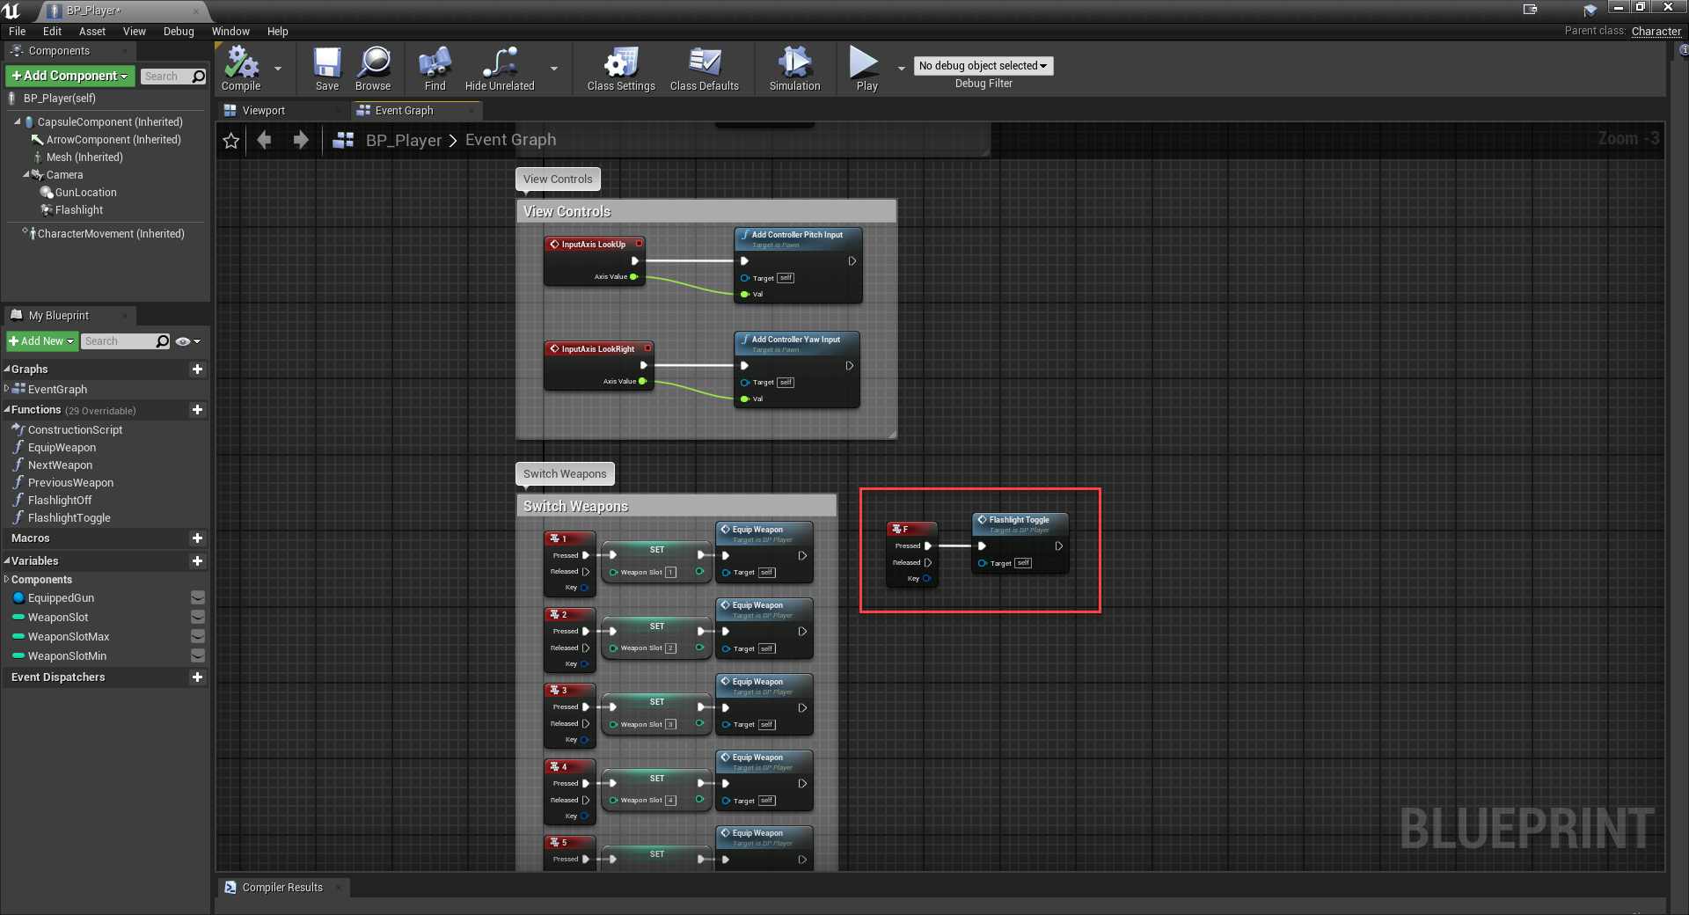

## Requirement: Terrain

**“A simple terrain that can host a game level.”**

Each level has a unique terrain which consists of mountains, trees, plants, and various ground materials to provide a sense of realism.

Jungle

Forest

# Functional Requirements – Assignment 2

## Requirement: New Level

**“Add at least a third level to the game with new look.”**

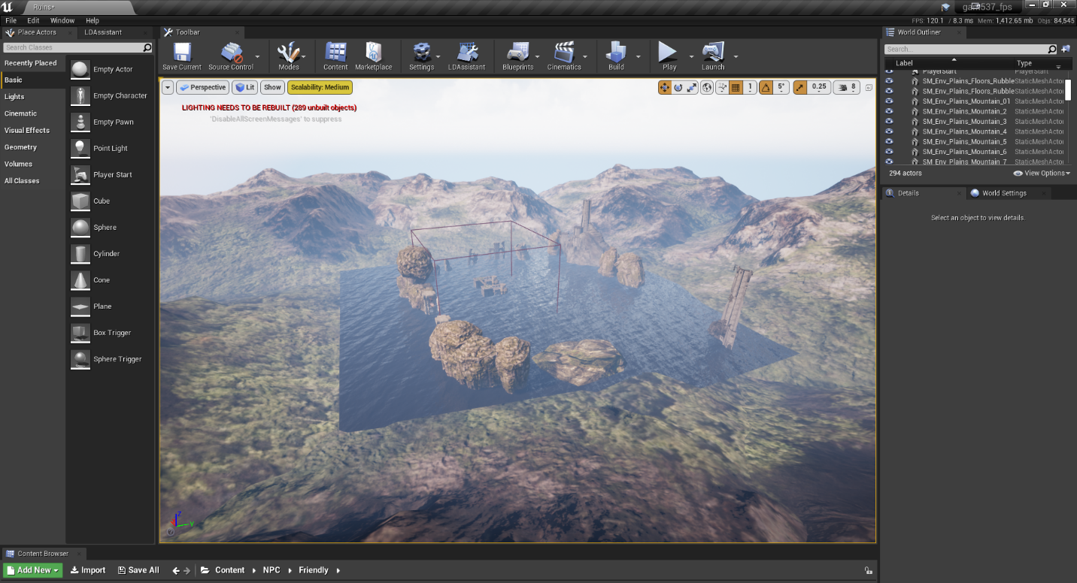

## Requirement: Game Character

**“Create a new Game Character, fully animated, with controls and camera. The animation should be realistic and the transitions logical and smooth. The Game Character should have a collider and should be fully interactive with the environment, other character and objects.”**

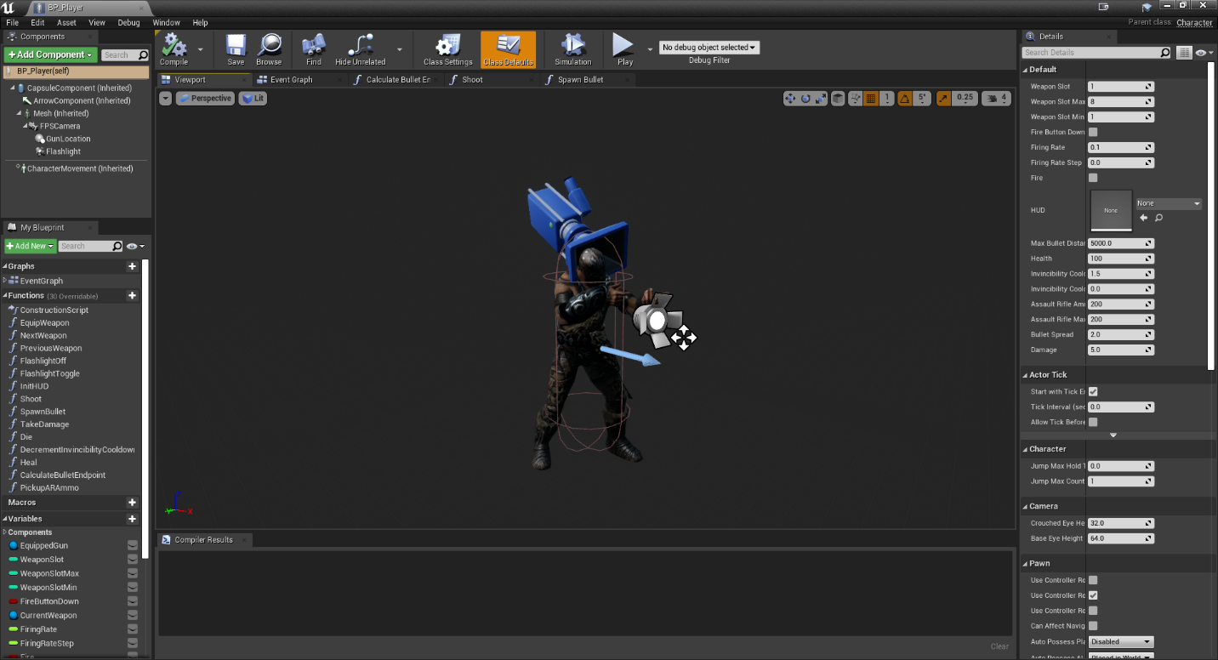

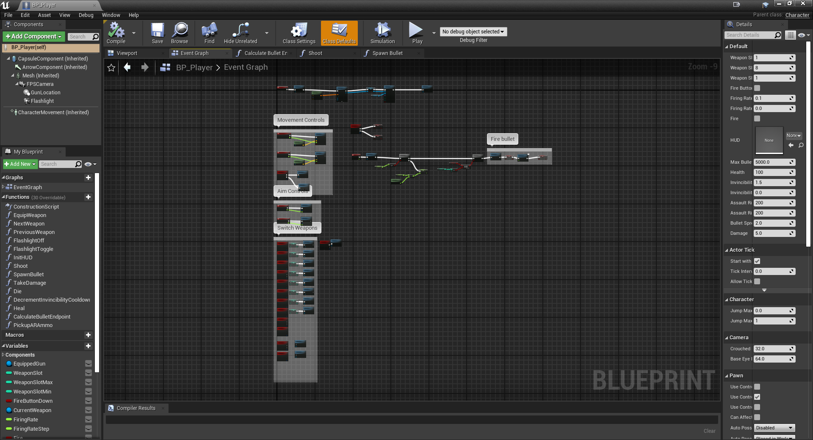

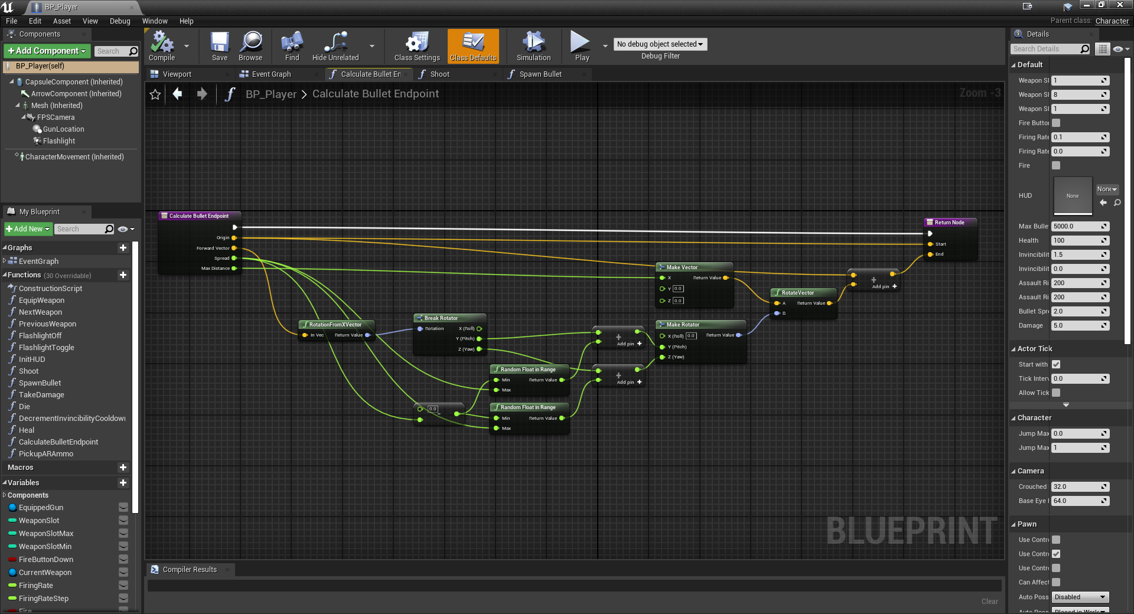

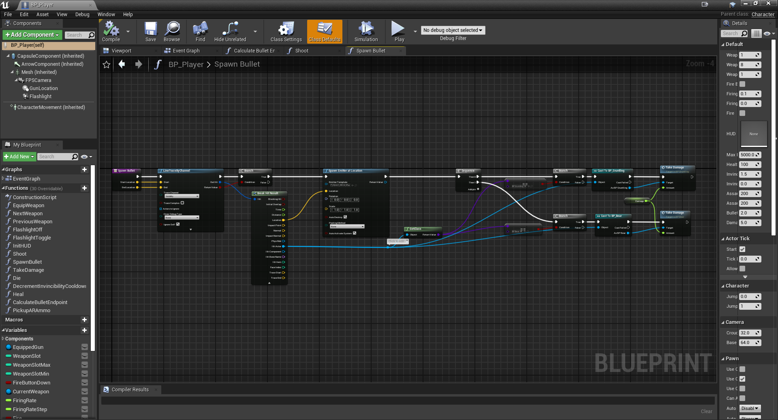

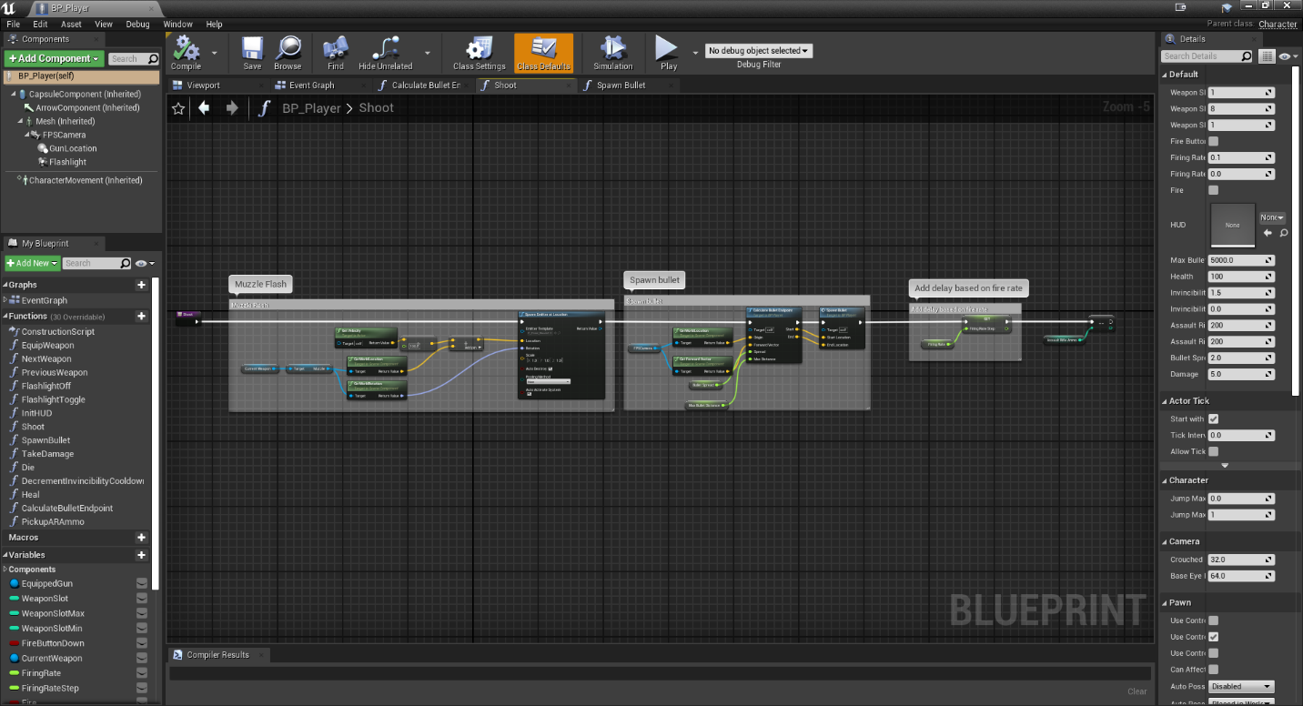

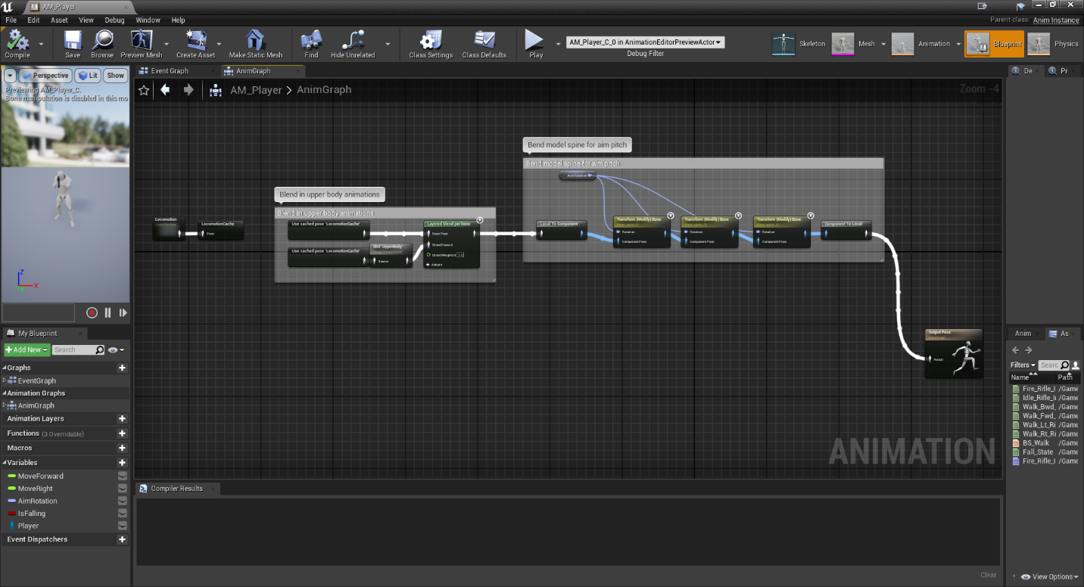

## Requirement: UI & HUD

**“The game should provide a working UI and a HUD (if applicable).”**

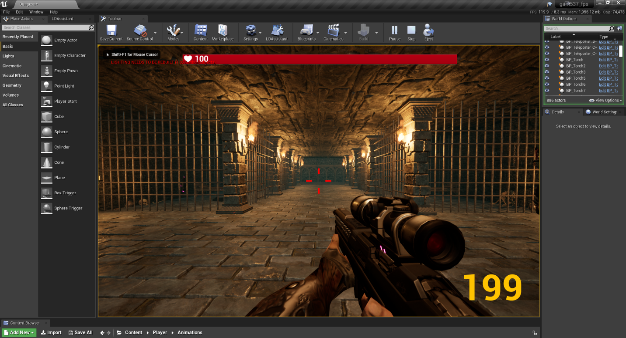

## Requirement: NPC’s and Enemies

**“Create at least 2 NPCs and 2 Enemies, fully animated, that move in the levels, but controlled by the computer (not AI needed).”**

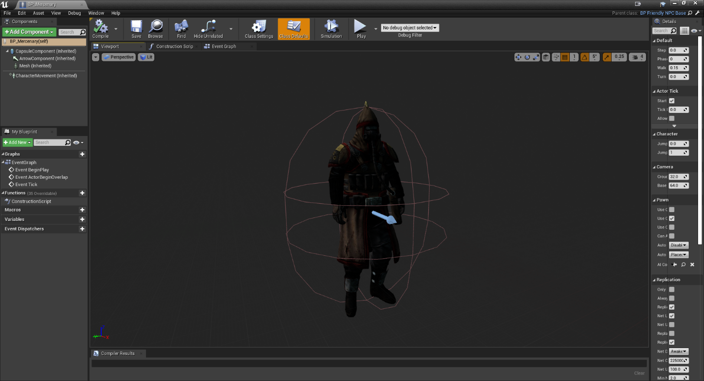

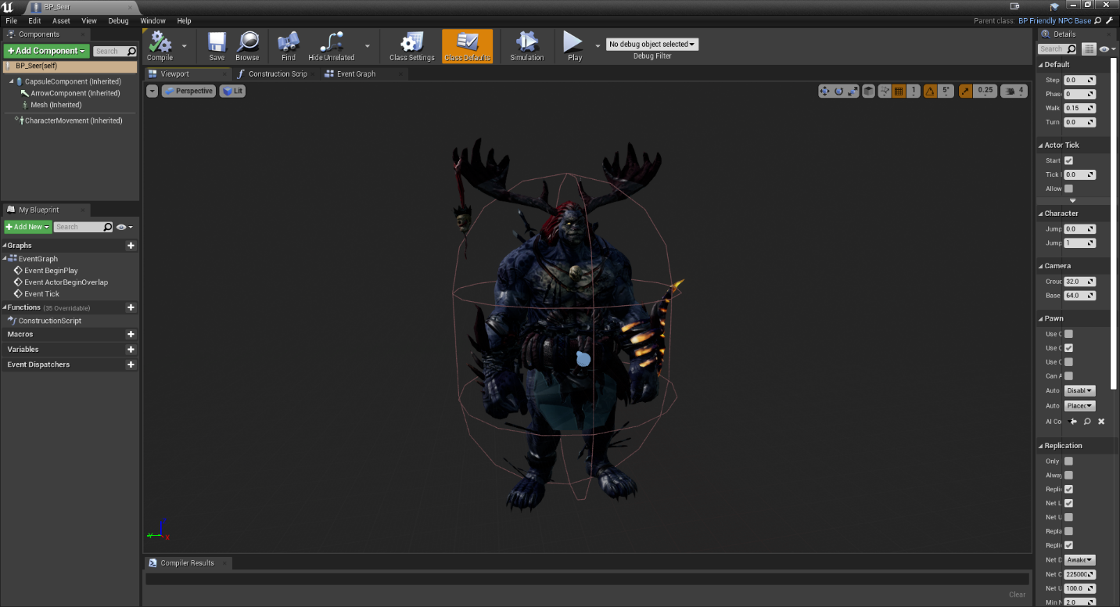

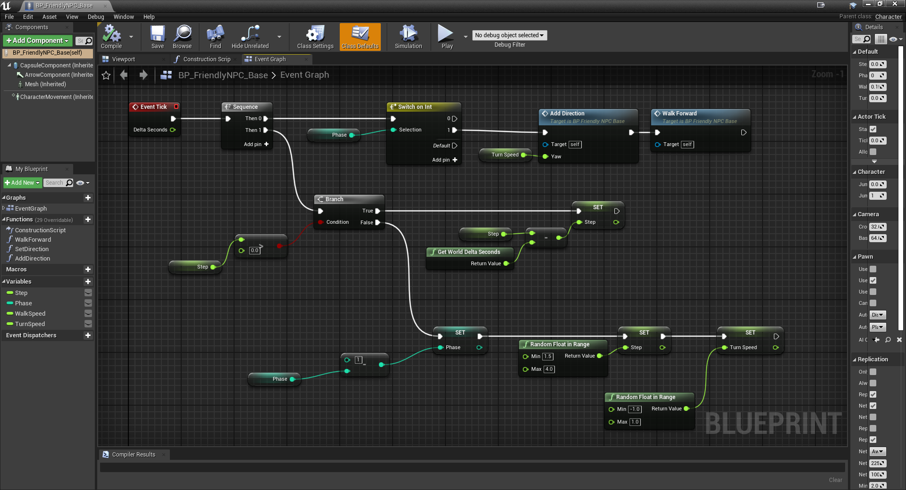

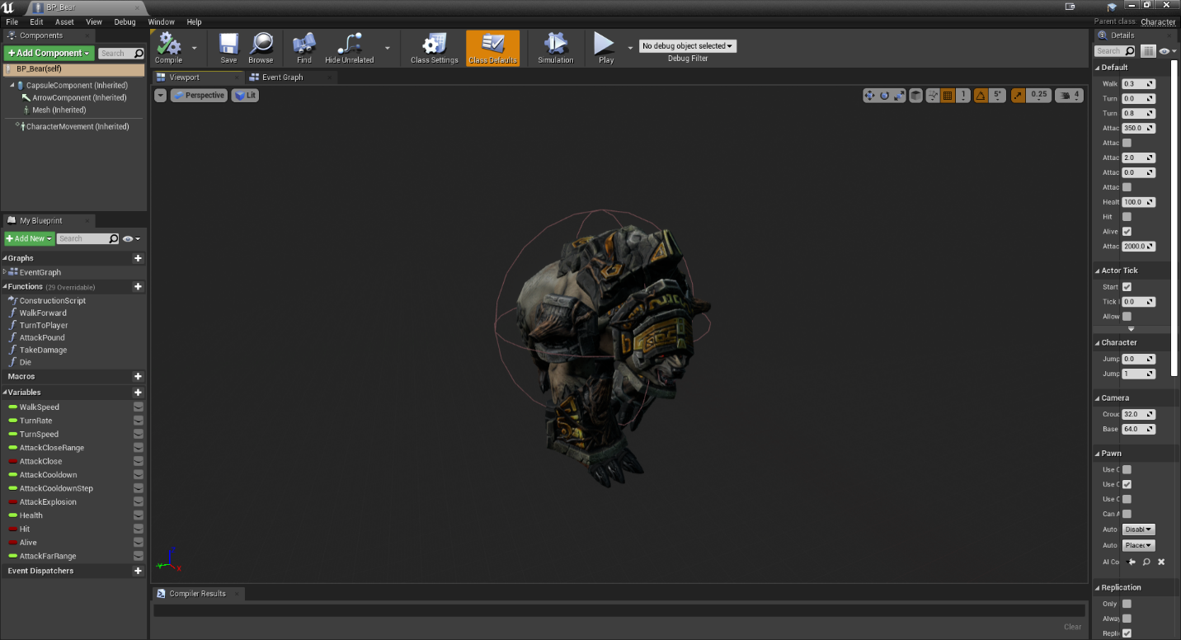

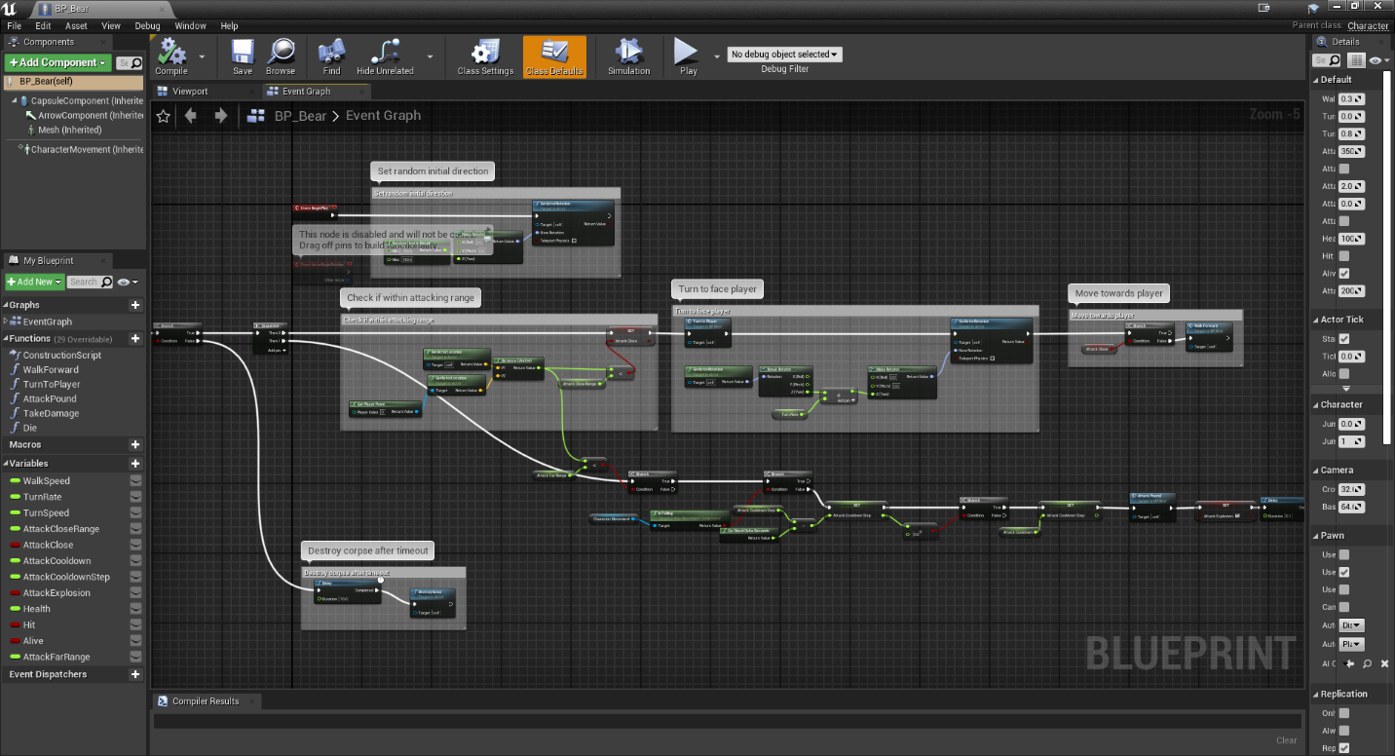

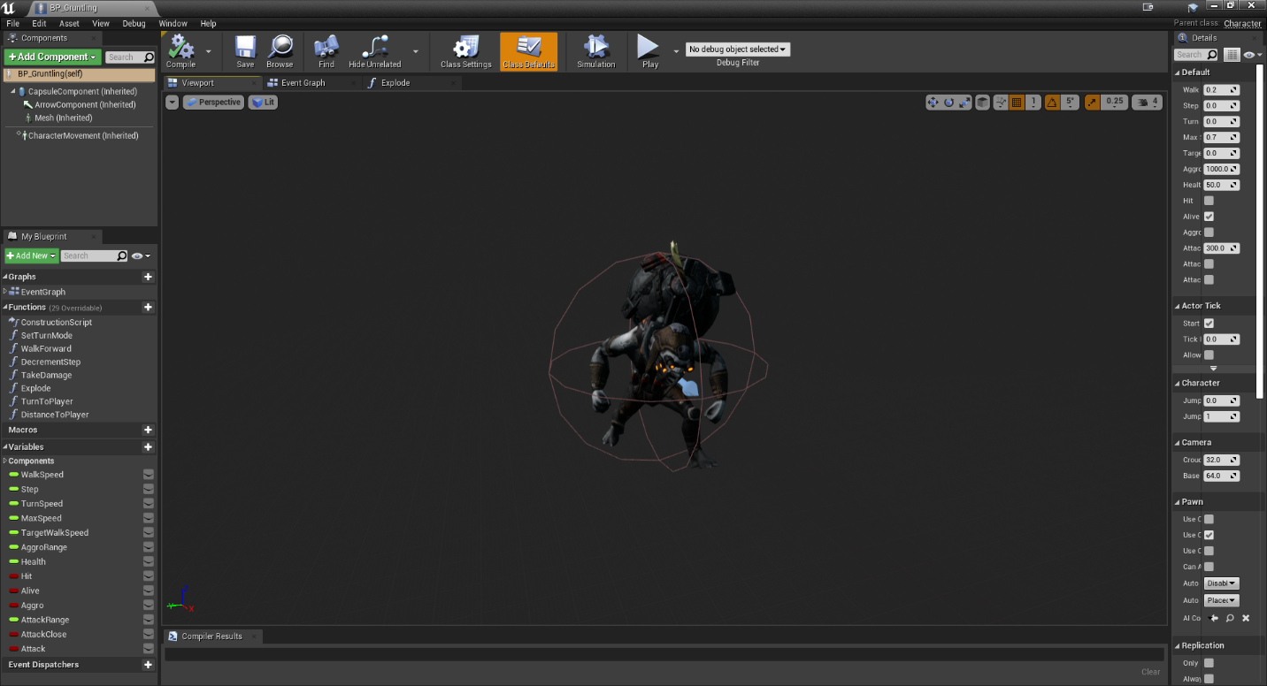

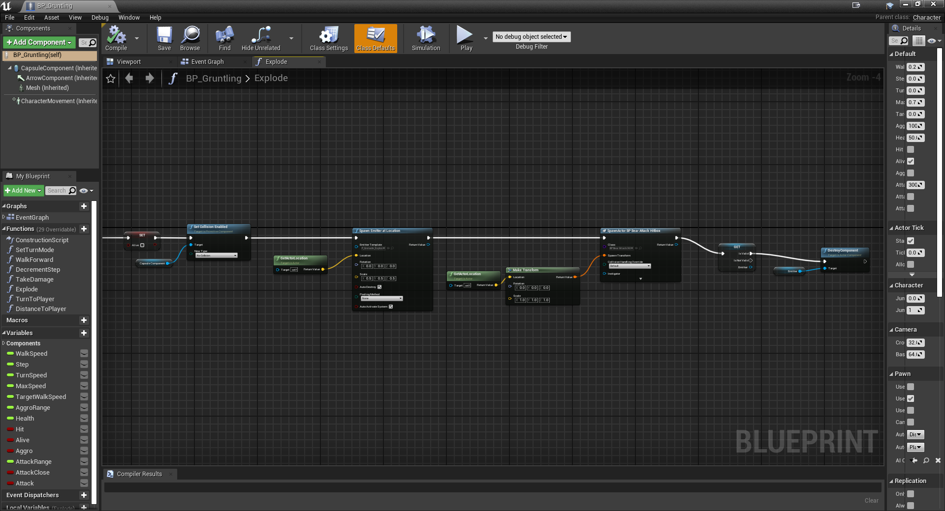

## Requirement: Landscapes

**“Create Landscapes for all the levels, with vegetation and/or object that populate the entire level.”**

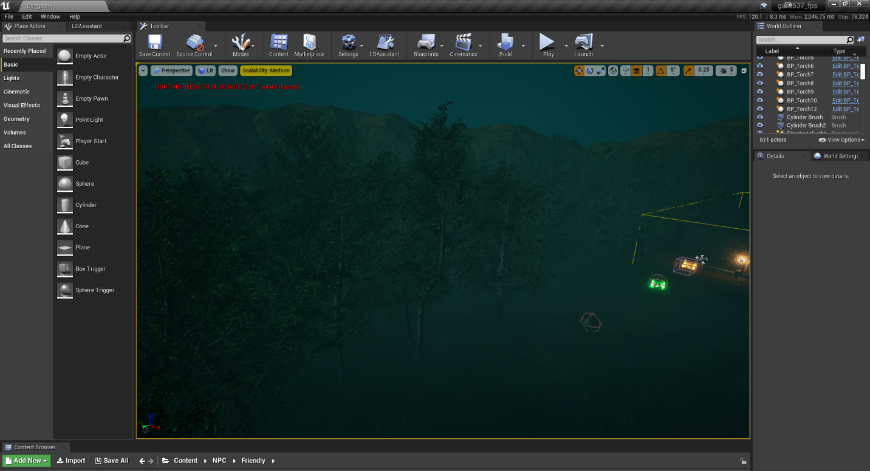

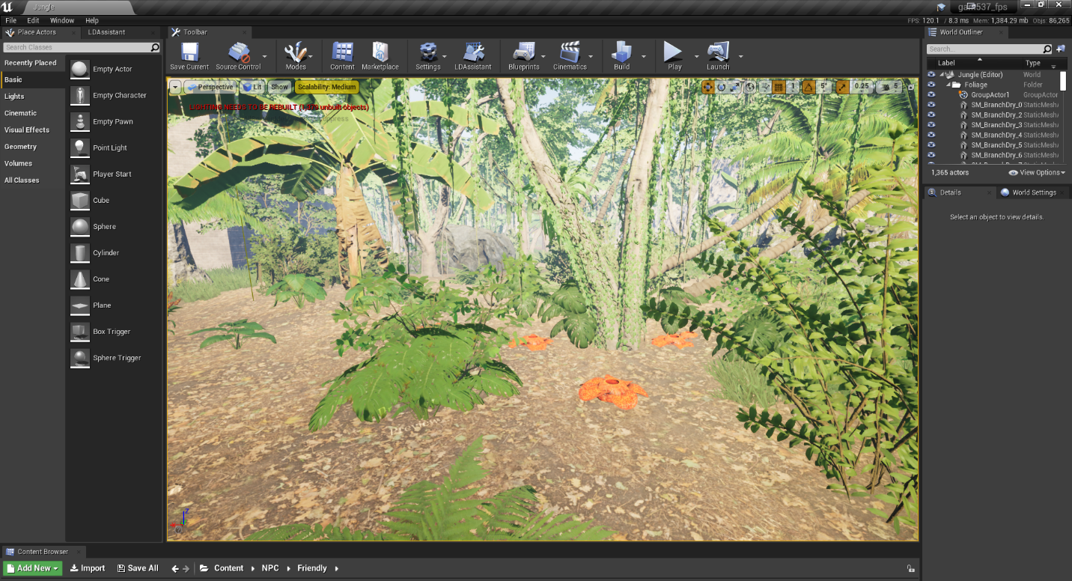

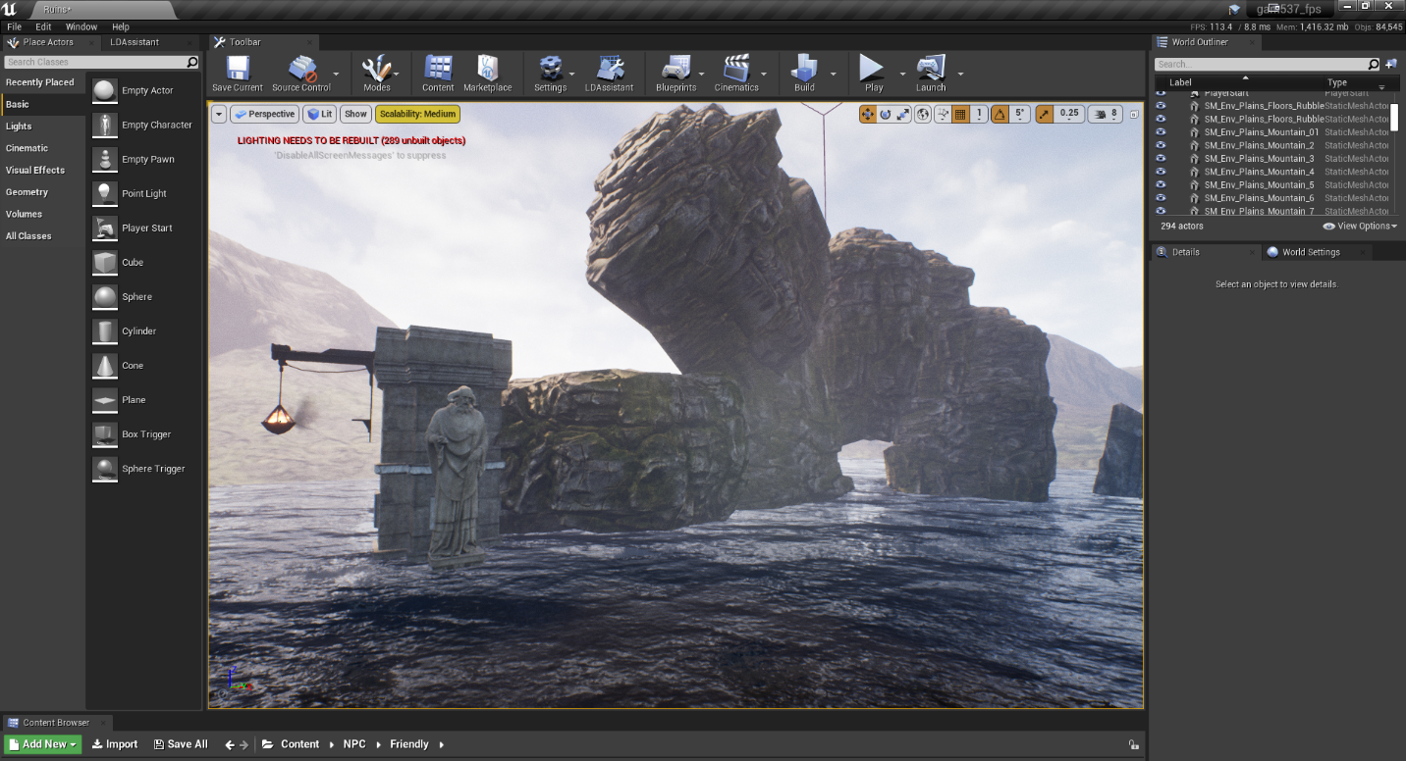

## Requirement: Lighting

**“Improve the look and atmosphere of your levels adding Volume and Lights.”**

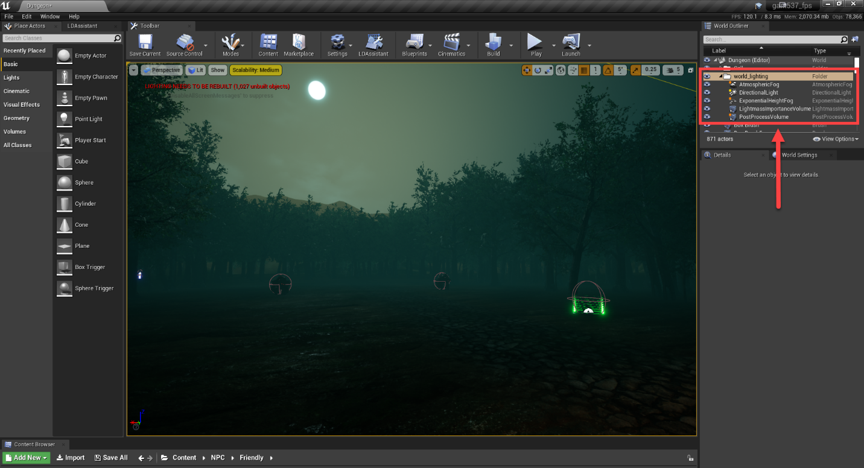

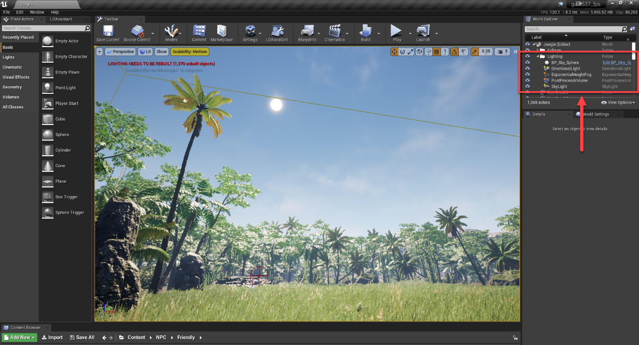

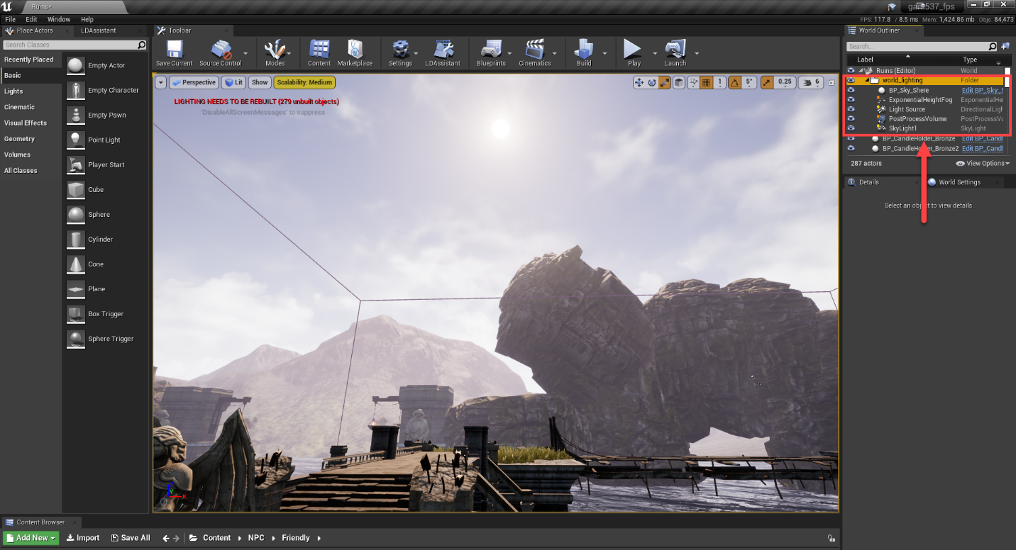

# Functional Requirements – Assignment 3

## Requirement: Animated Character

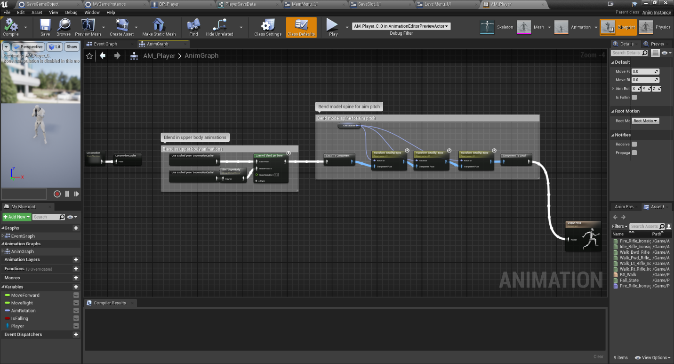

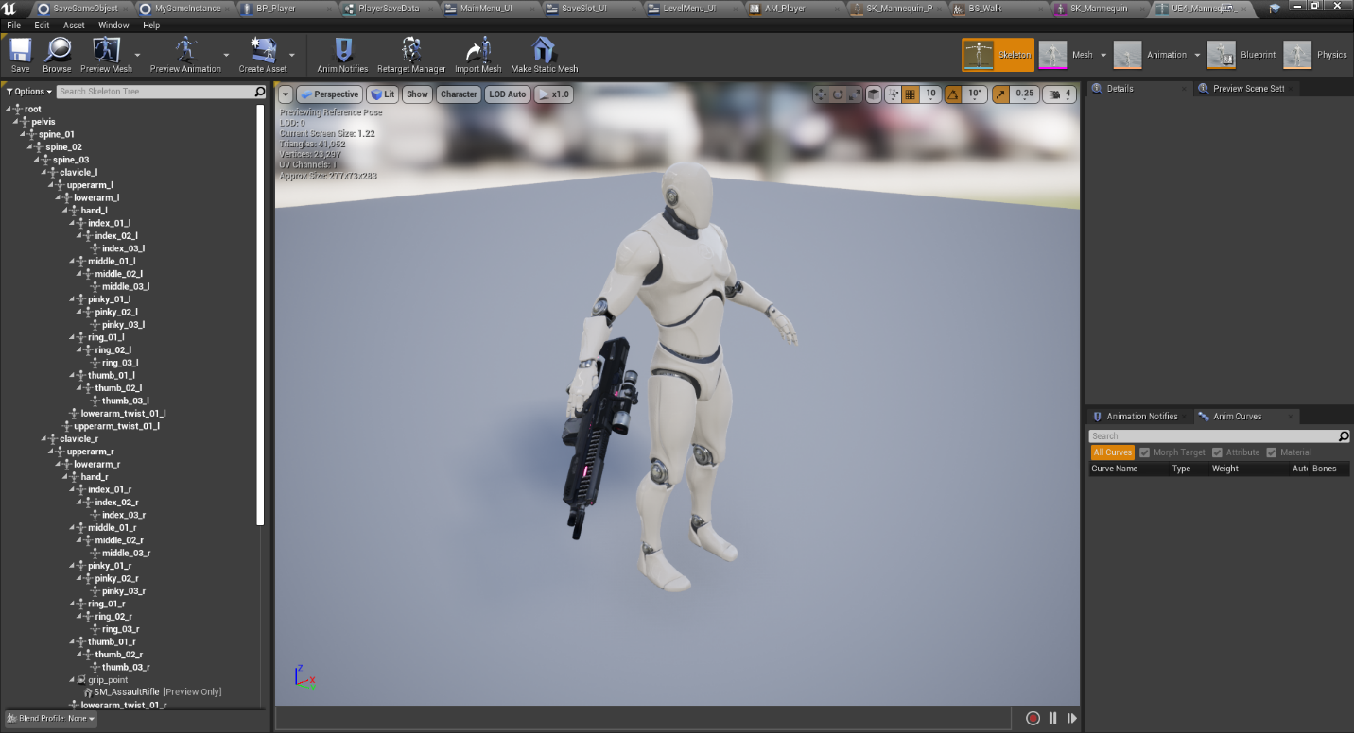

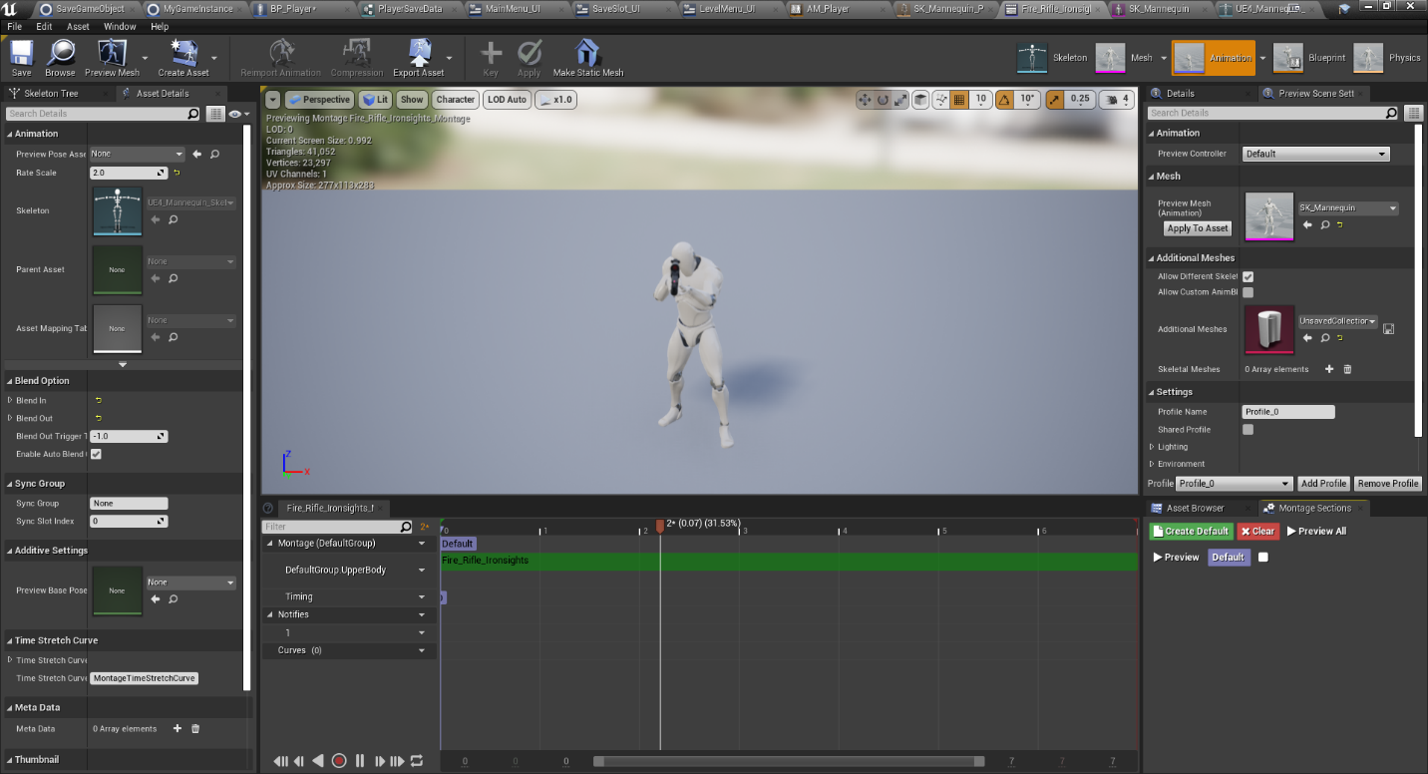

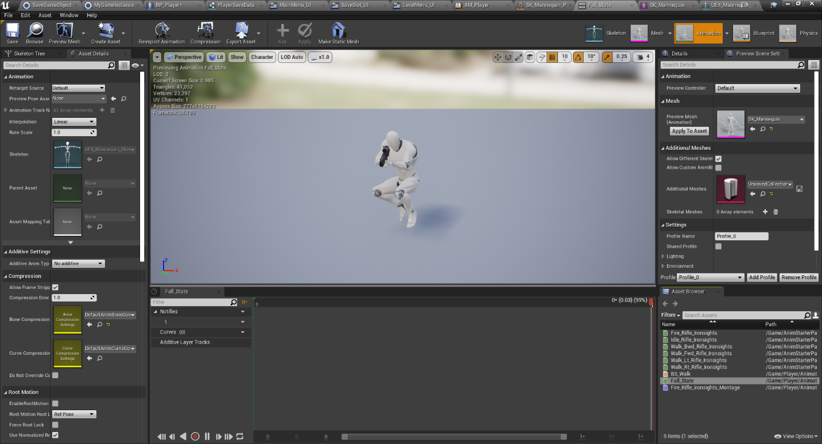

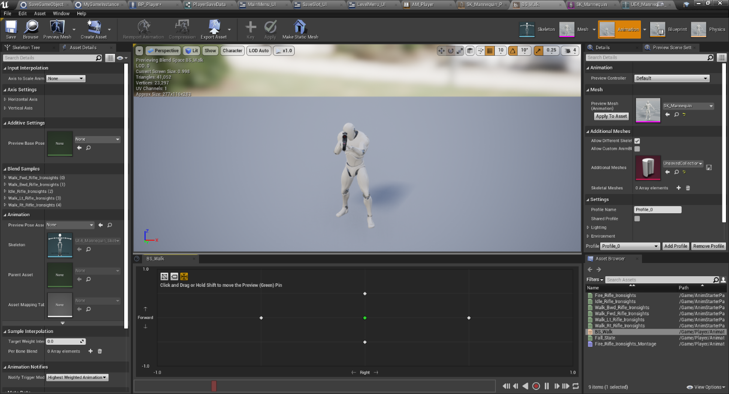

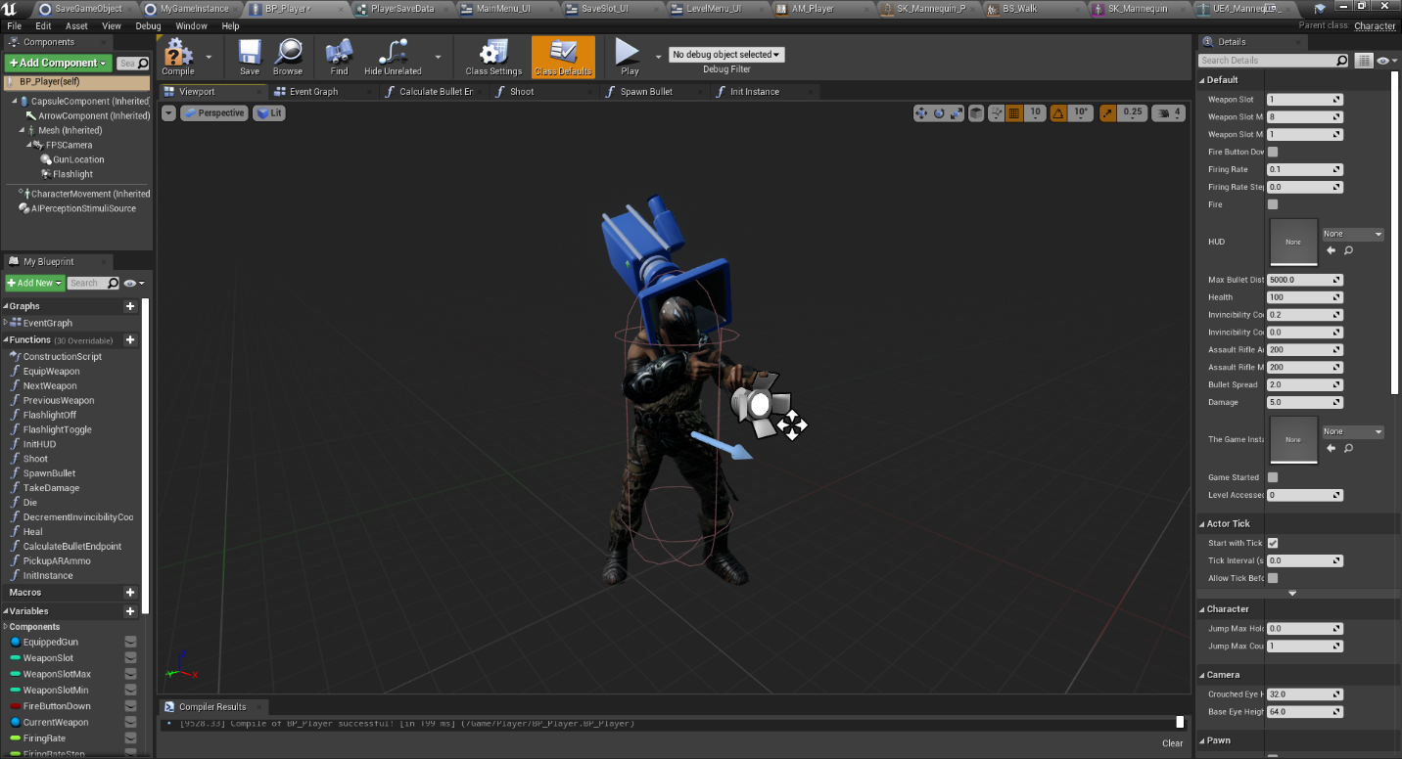

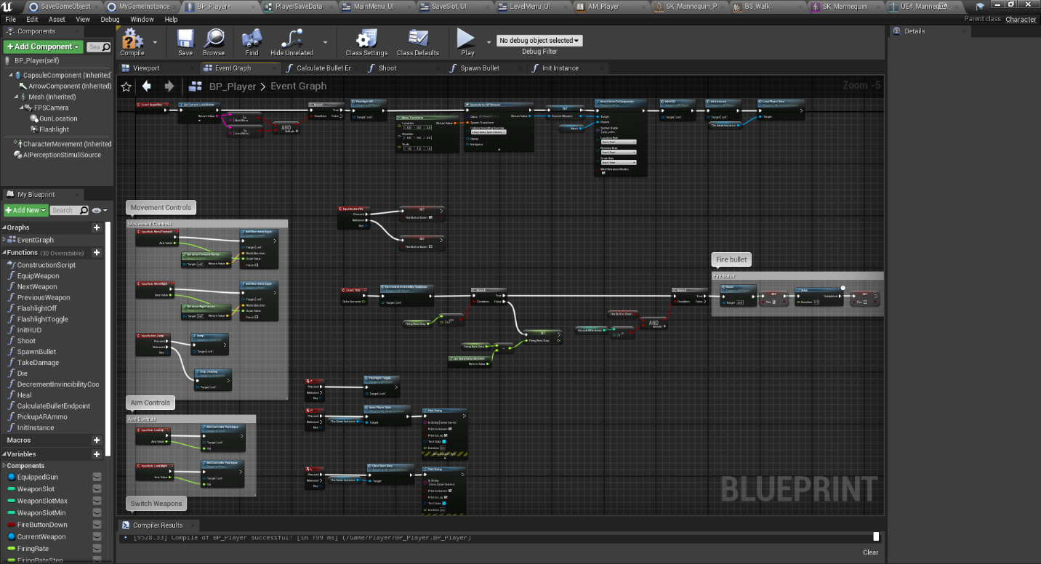

## Requirement: Fully animated NPC’s and Enemies

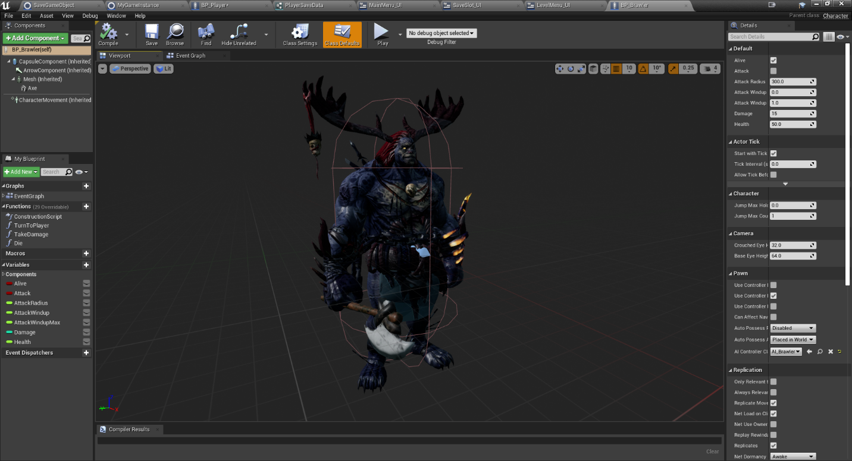

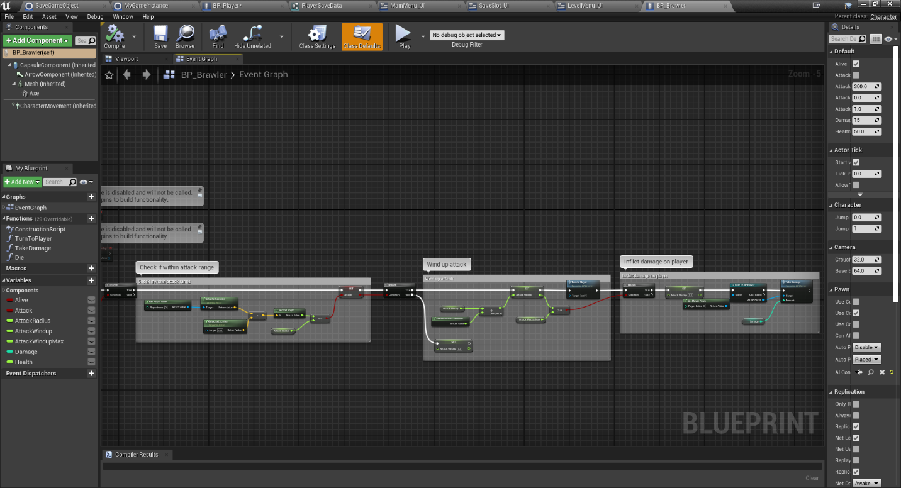

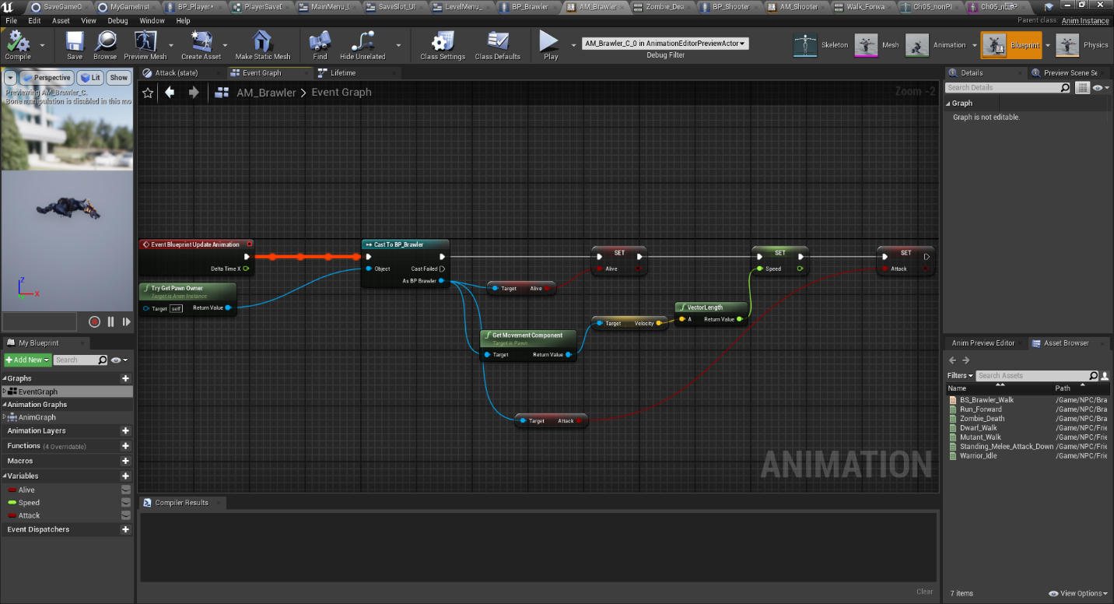

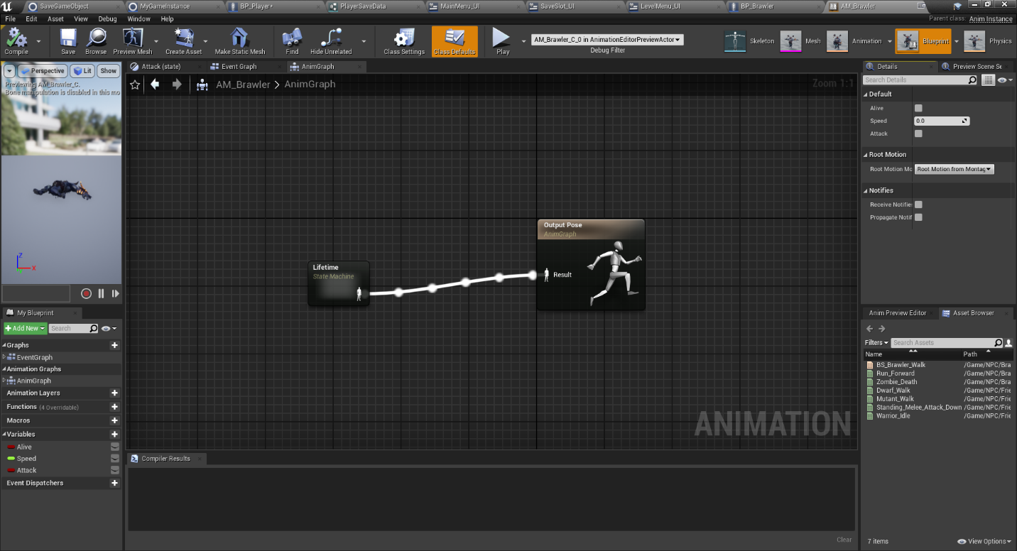

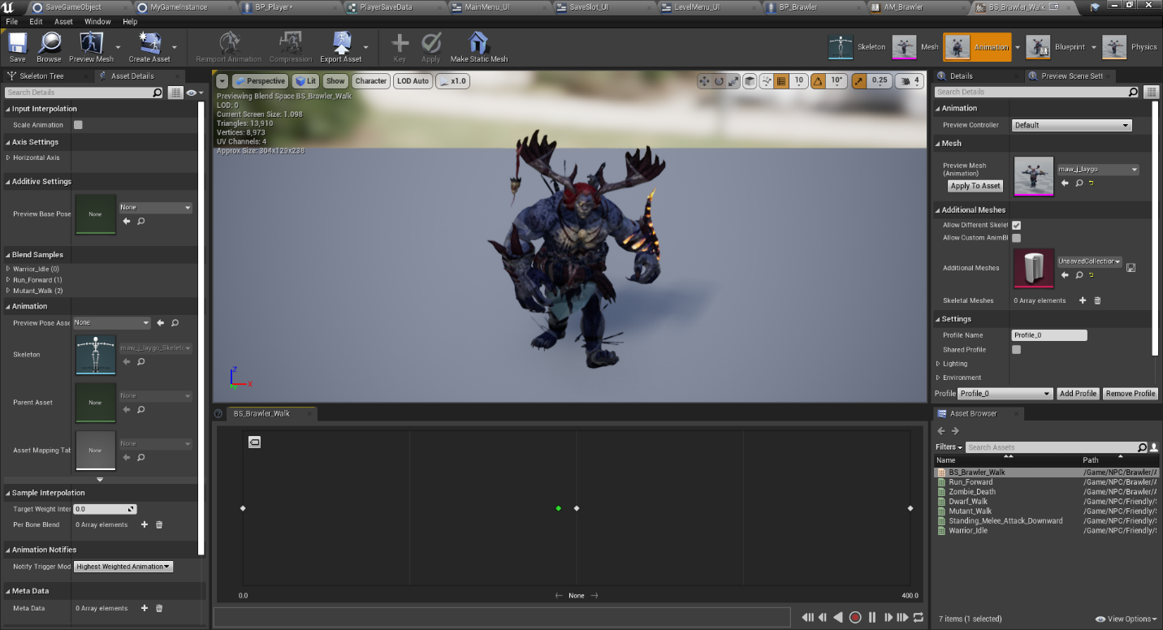

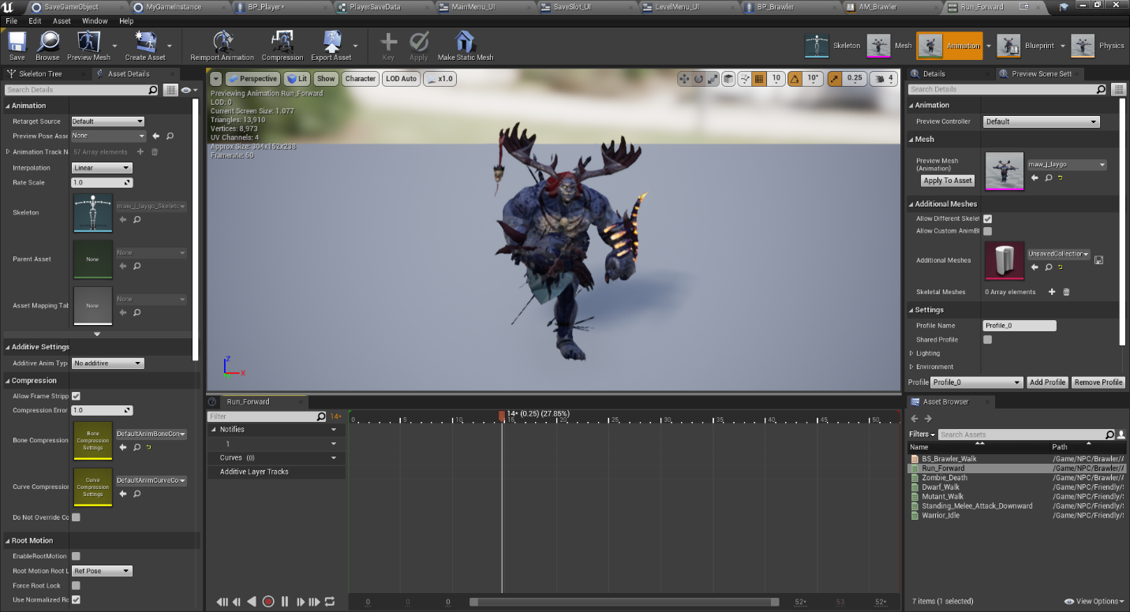

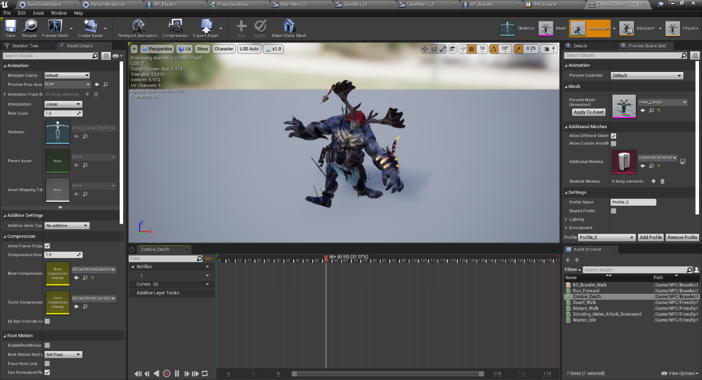

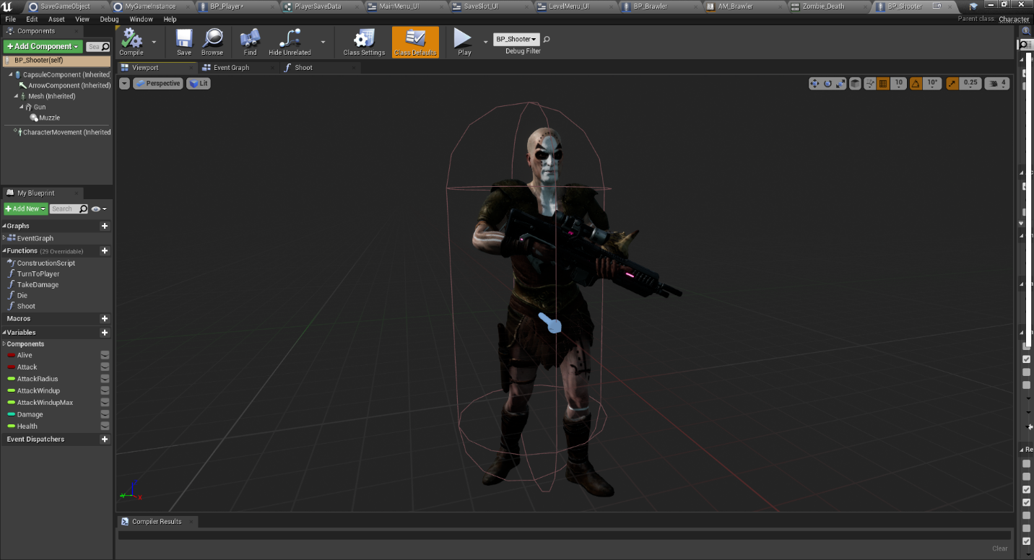

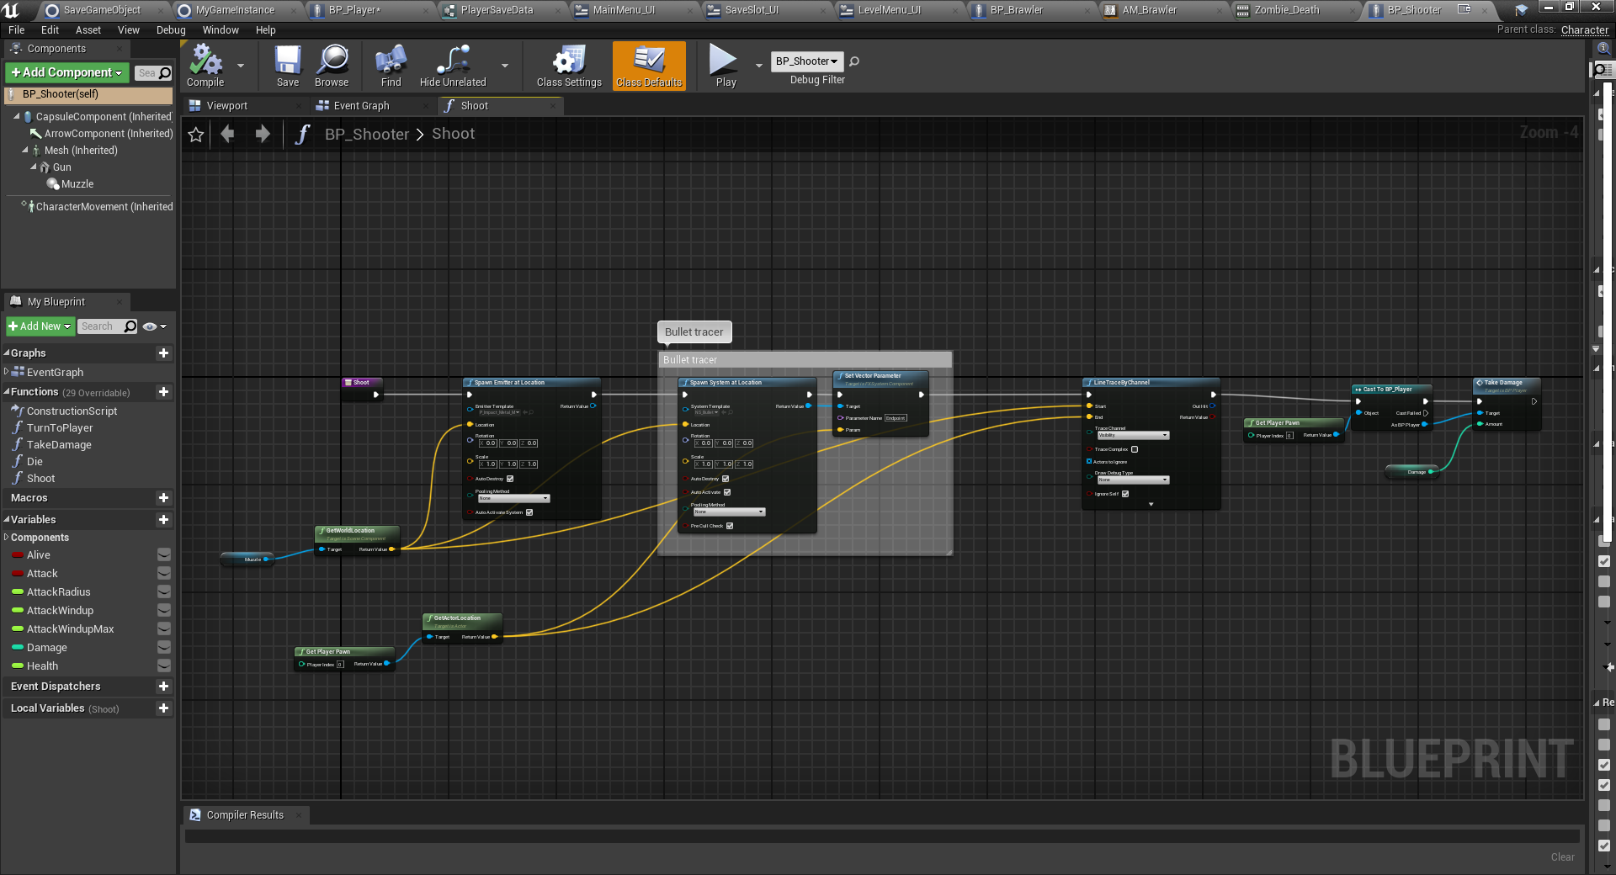

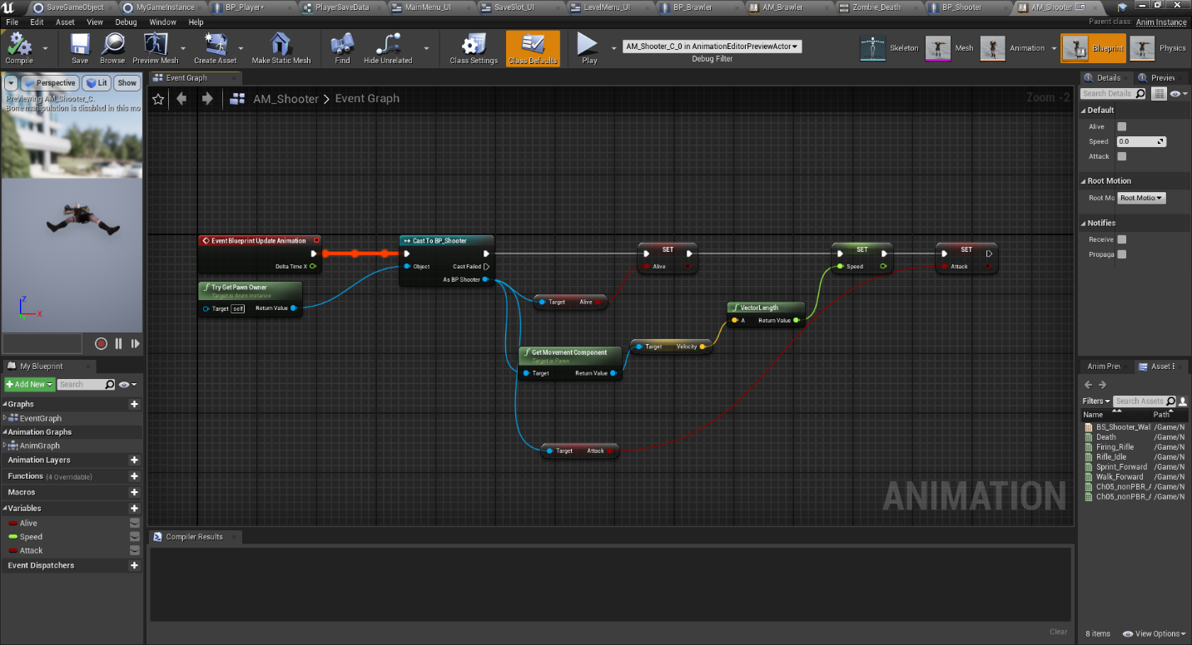

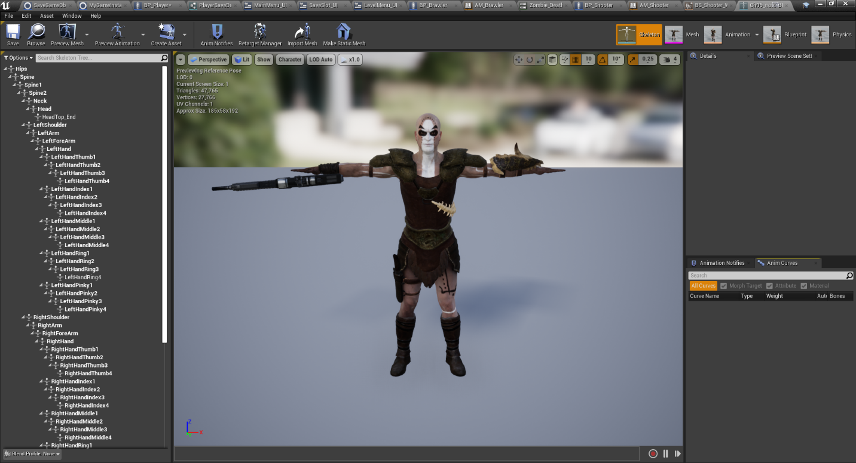

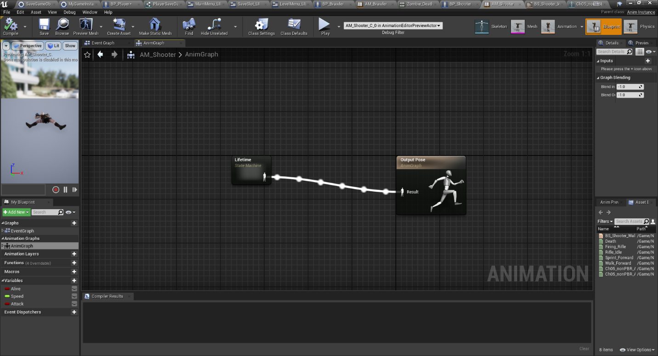

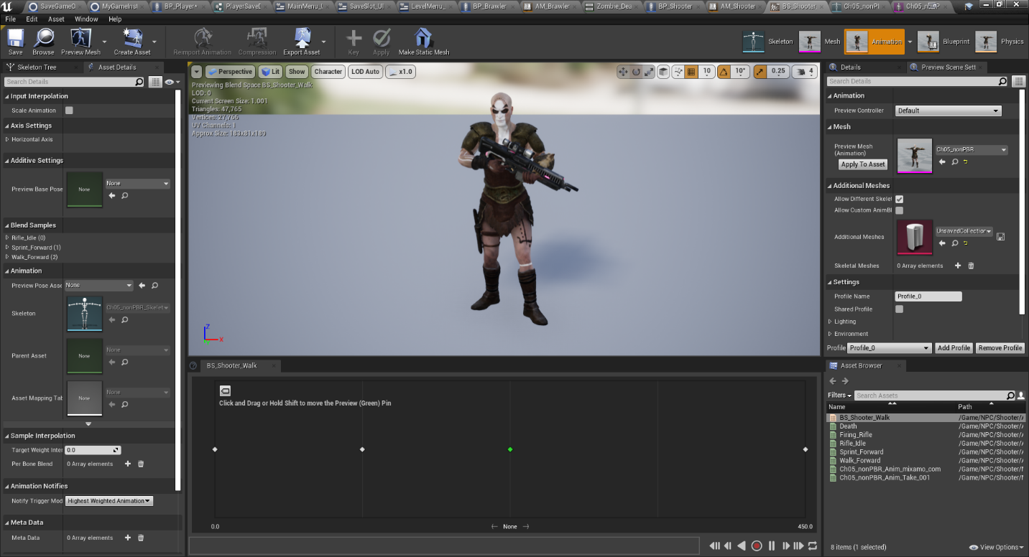

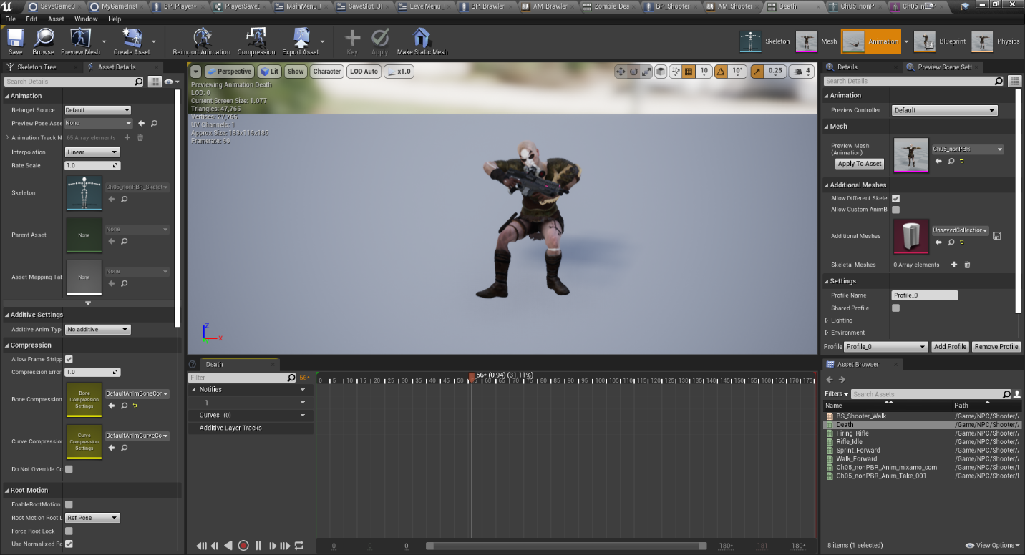

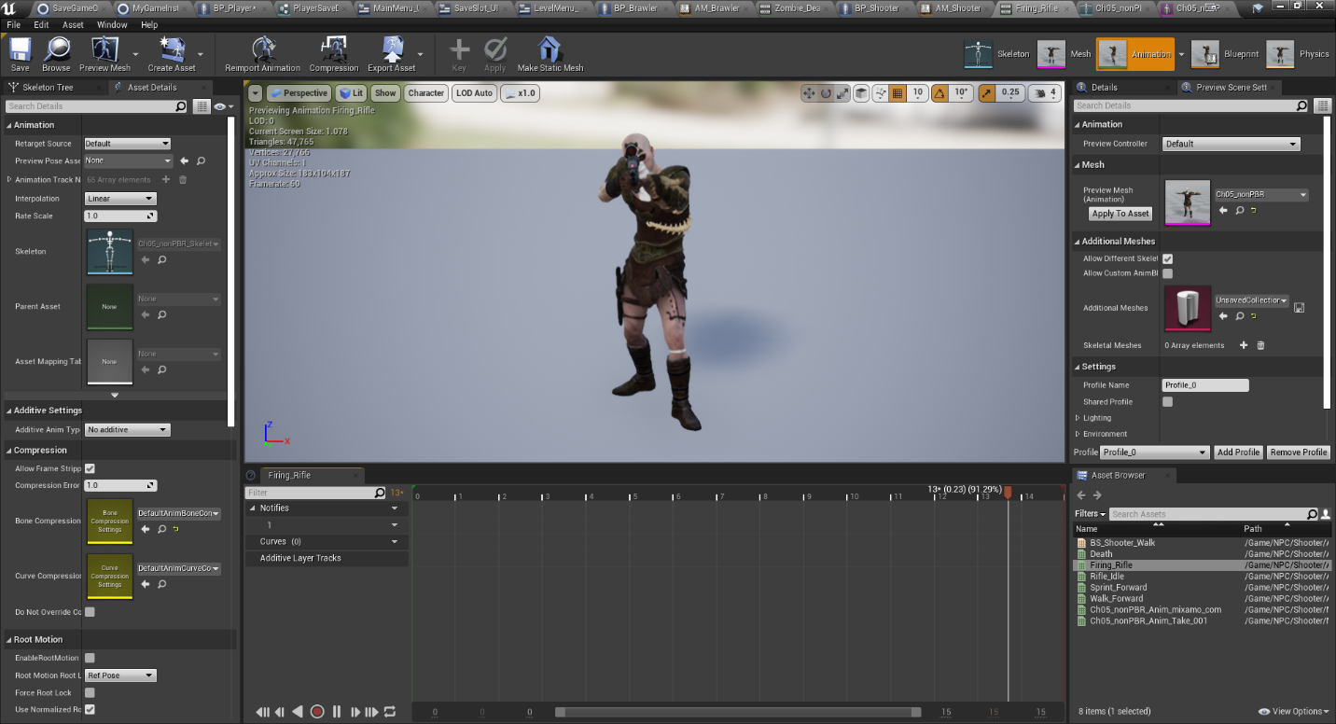

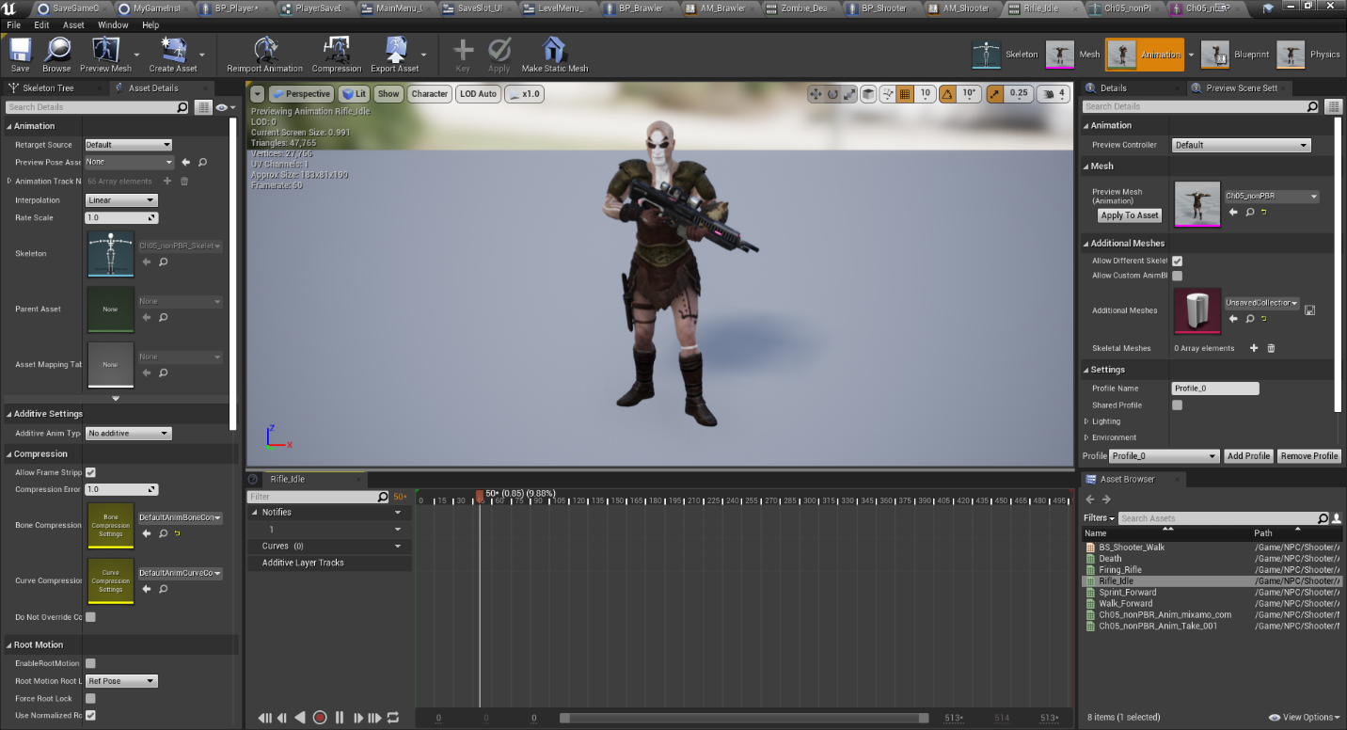

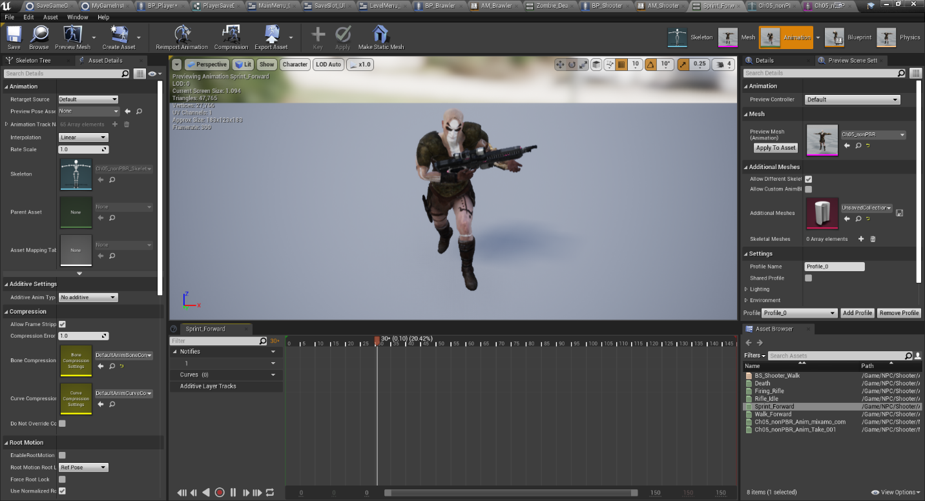

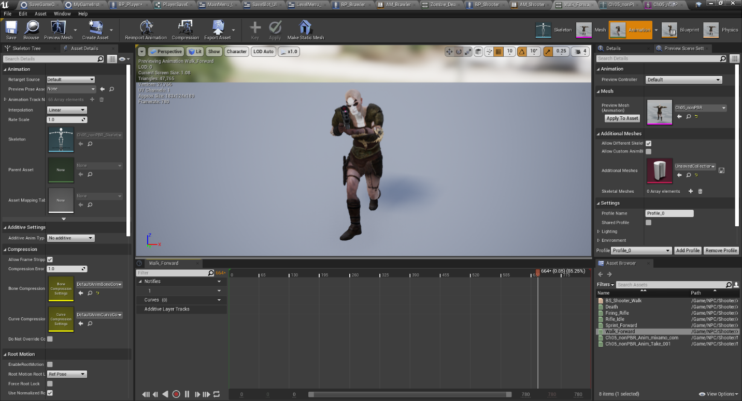

## Requirement: Added AI Logic to Enemies/NPC’s

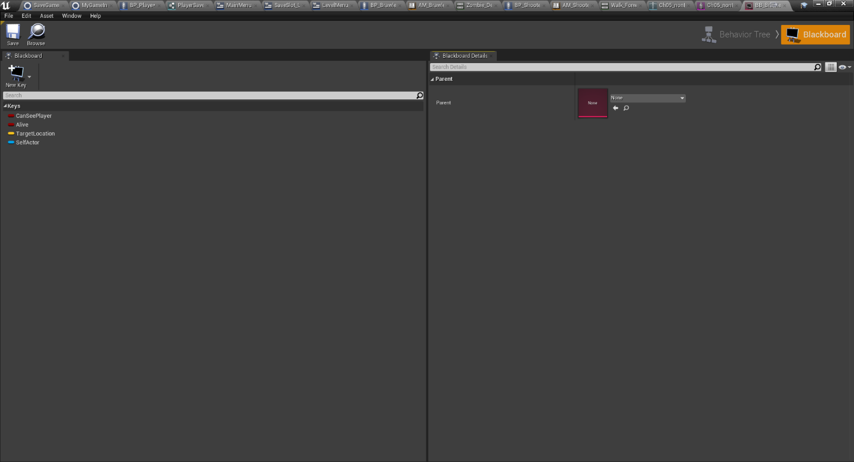

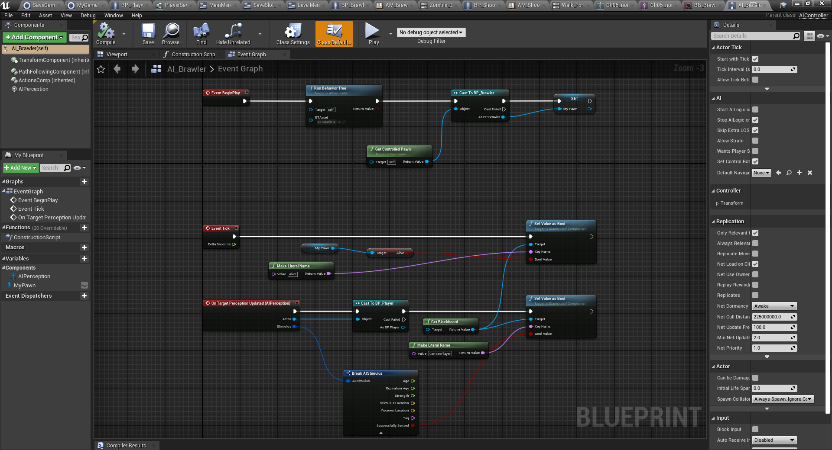

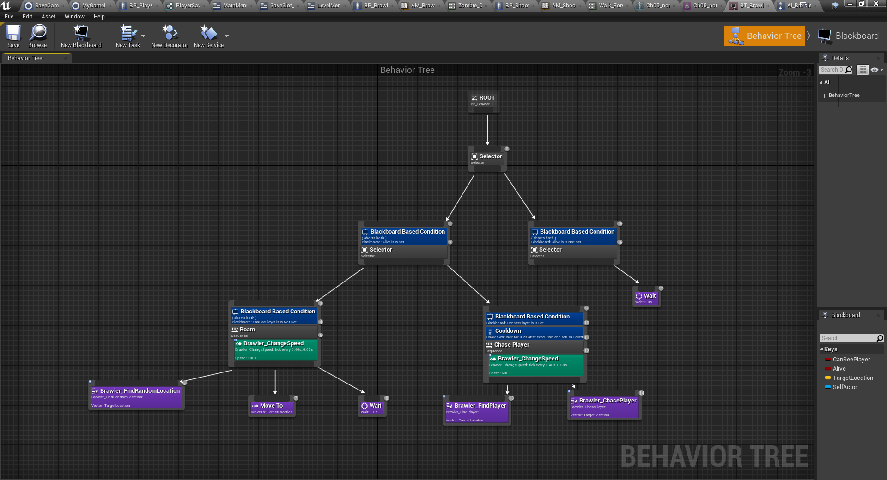

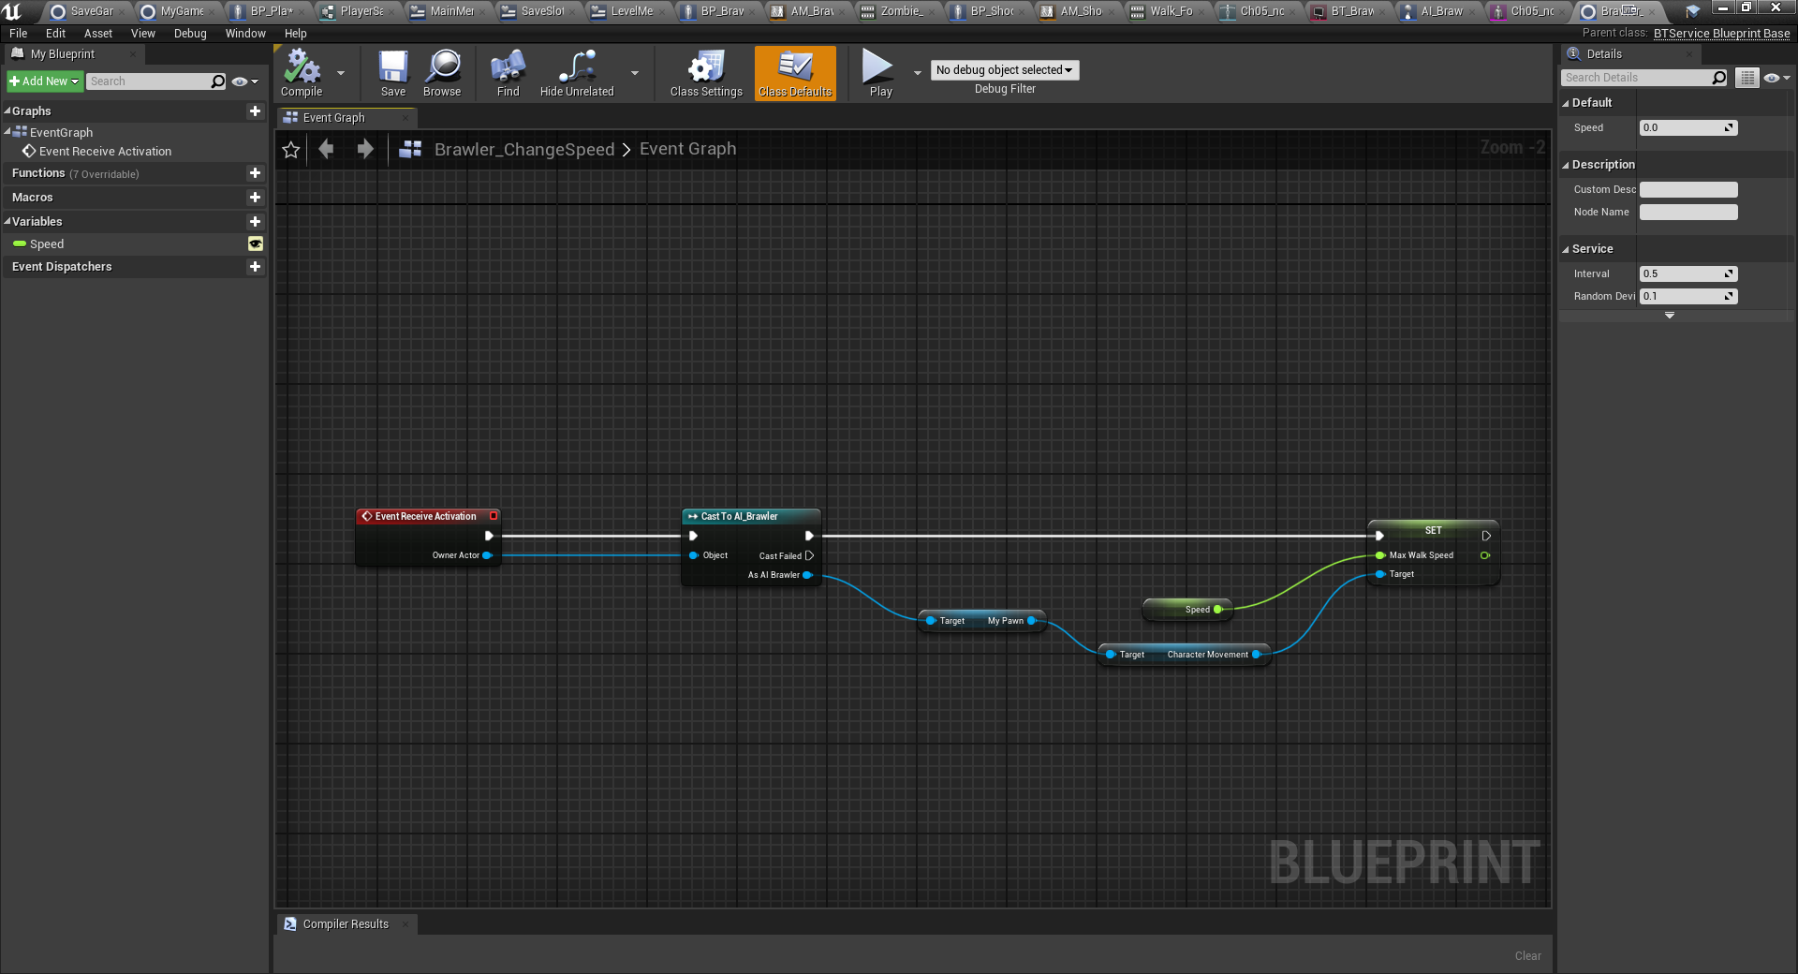

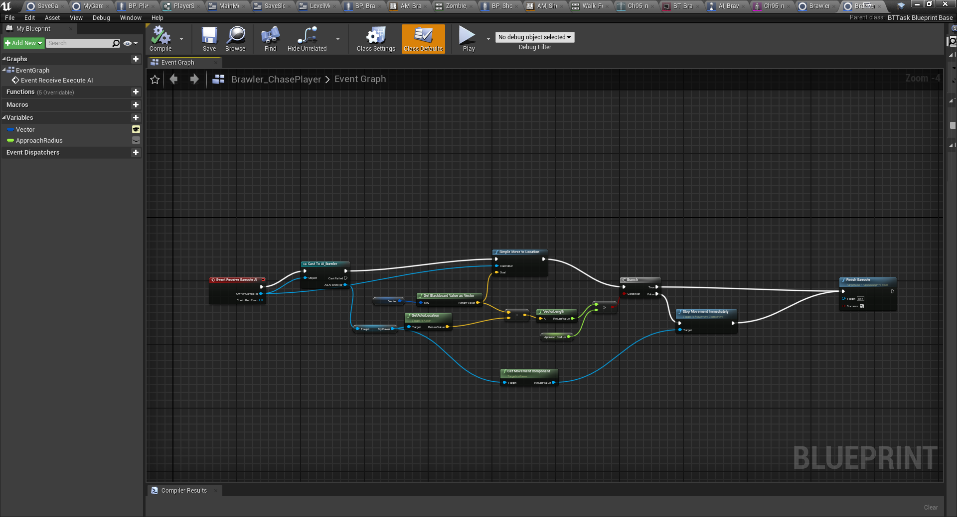

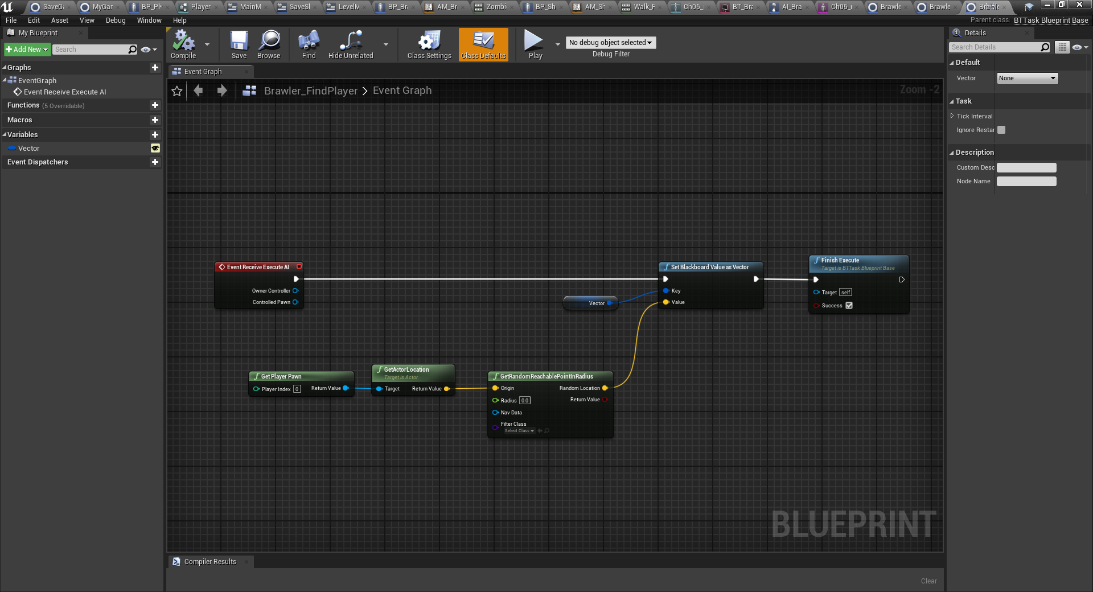

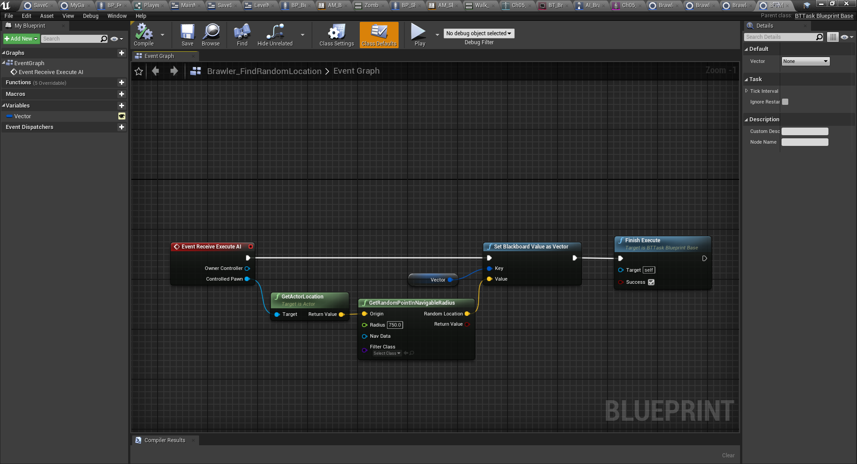

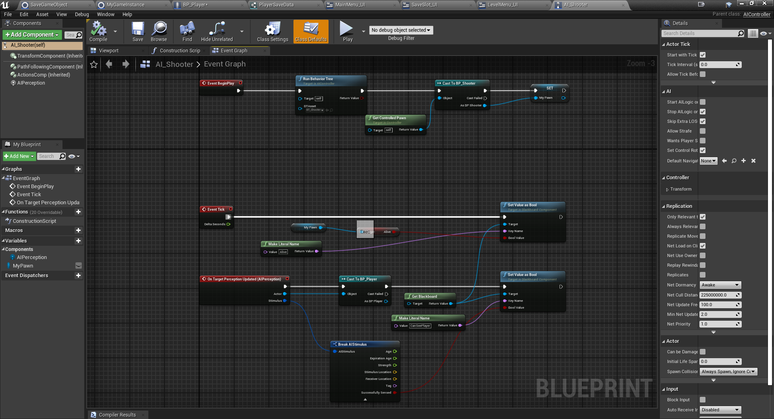

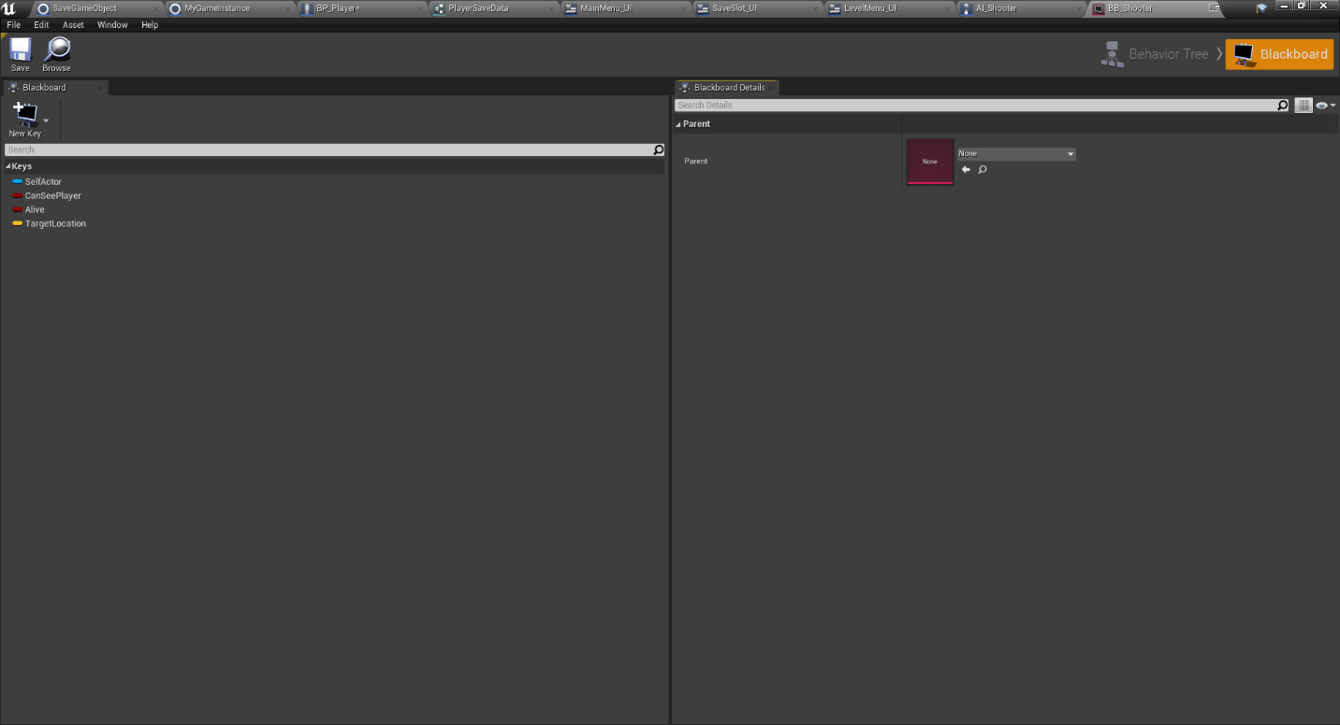

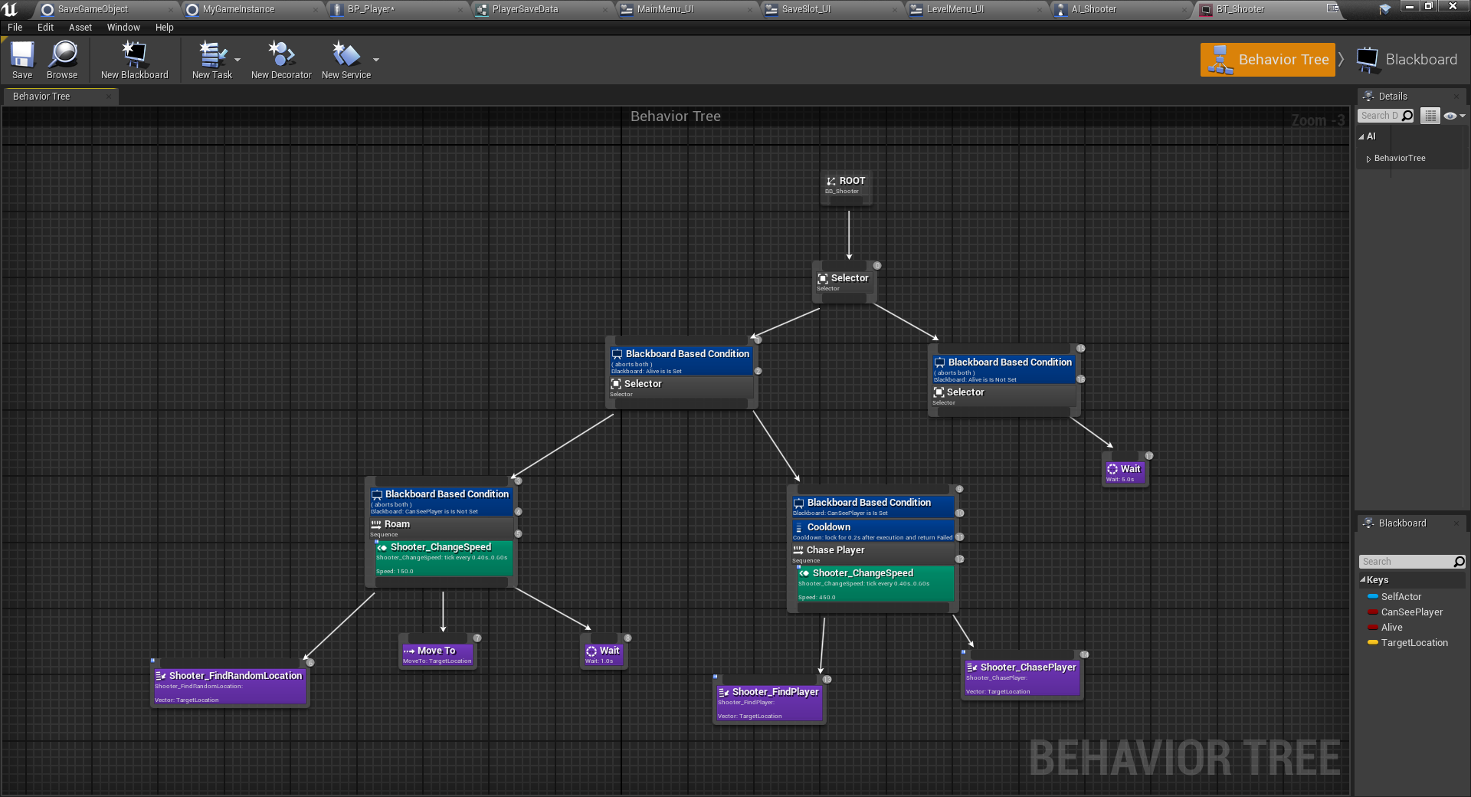

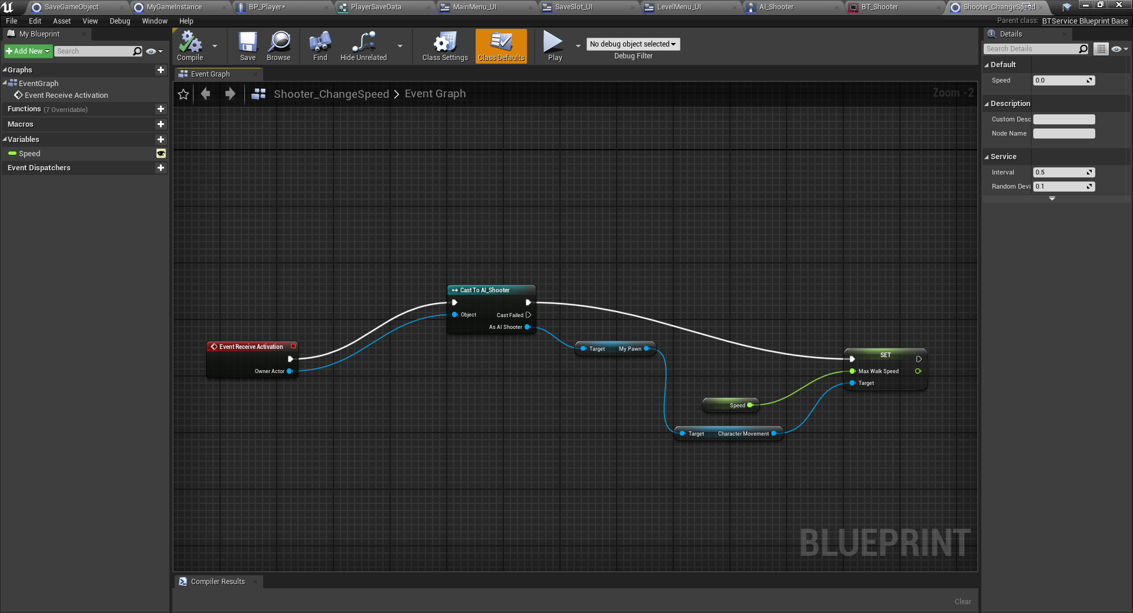

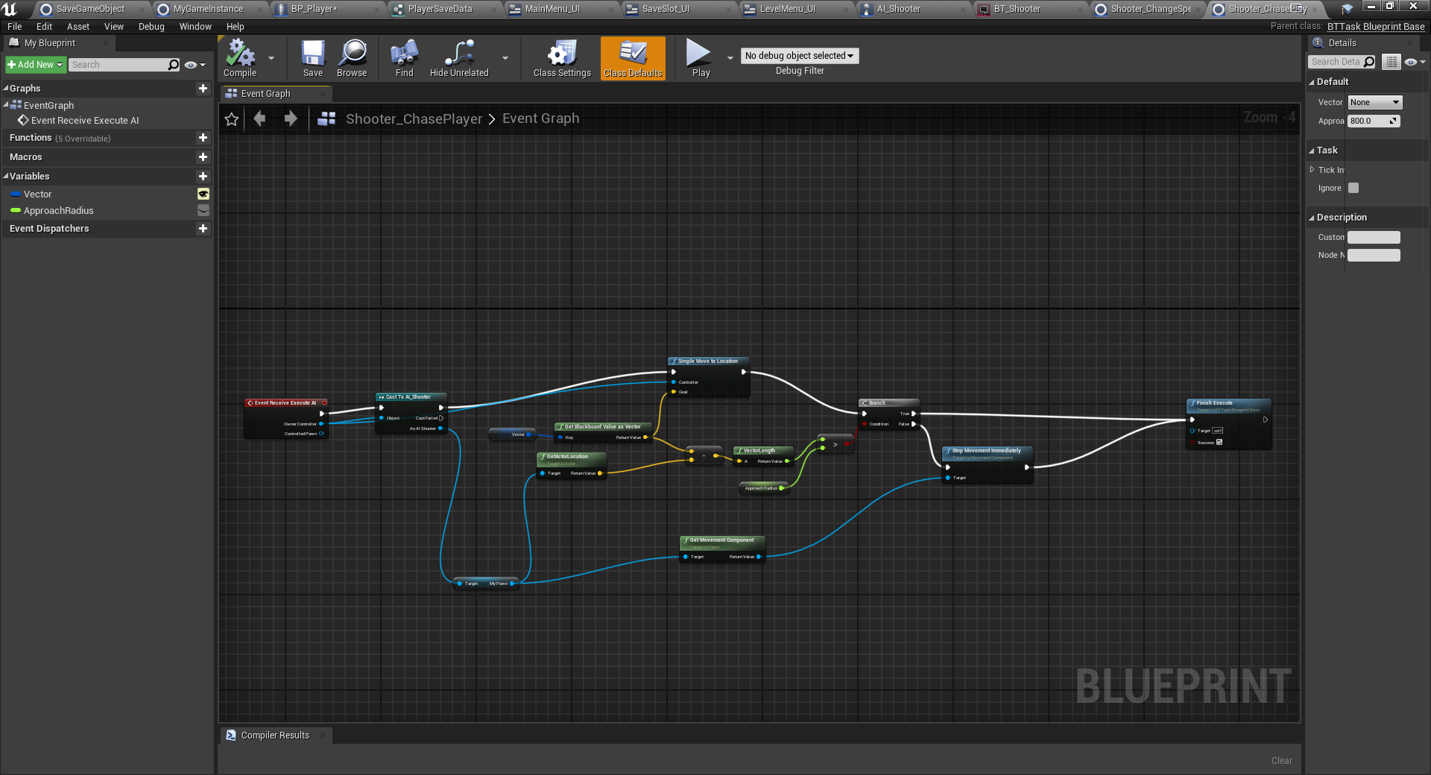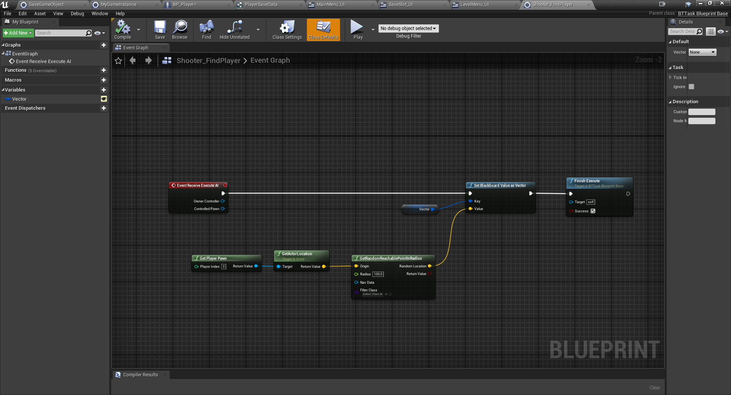

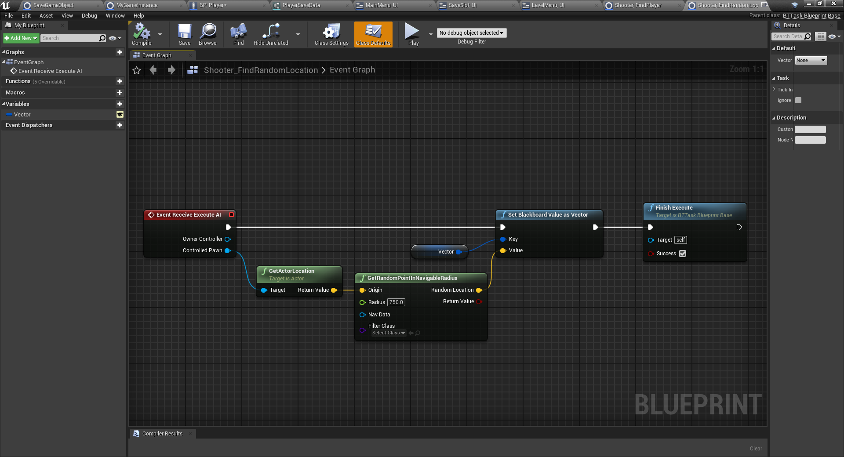

## Requirement: Save & Load Functionality

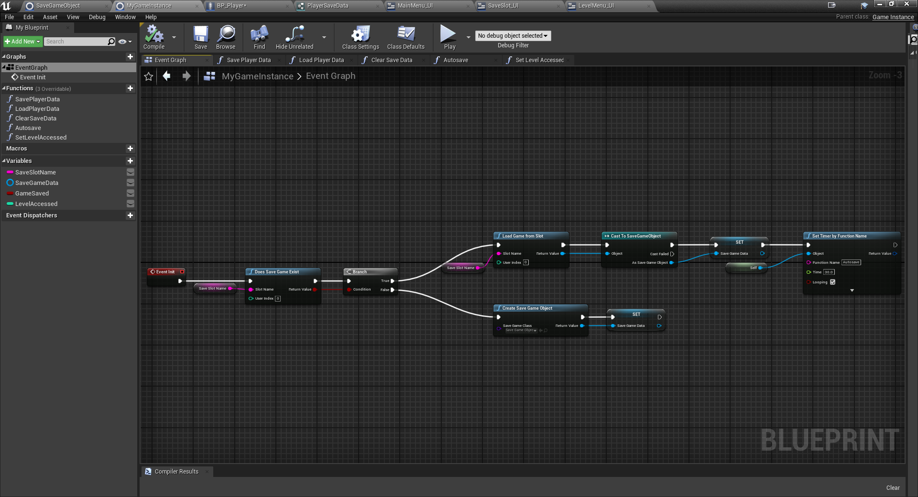

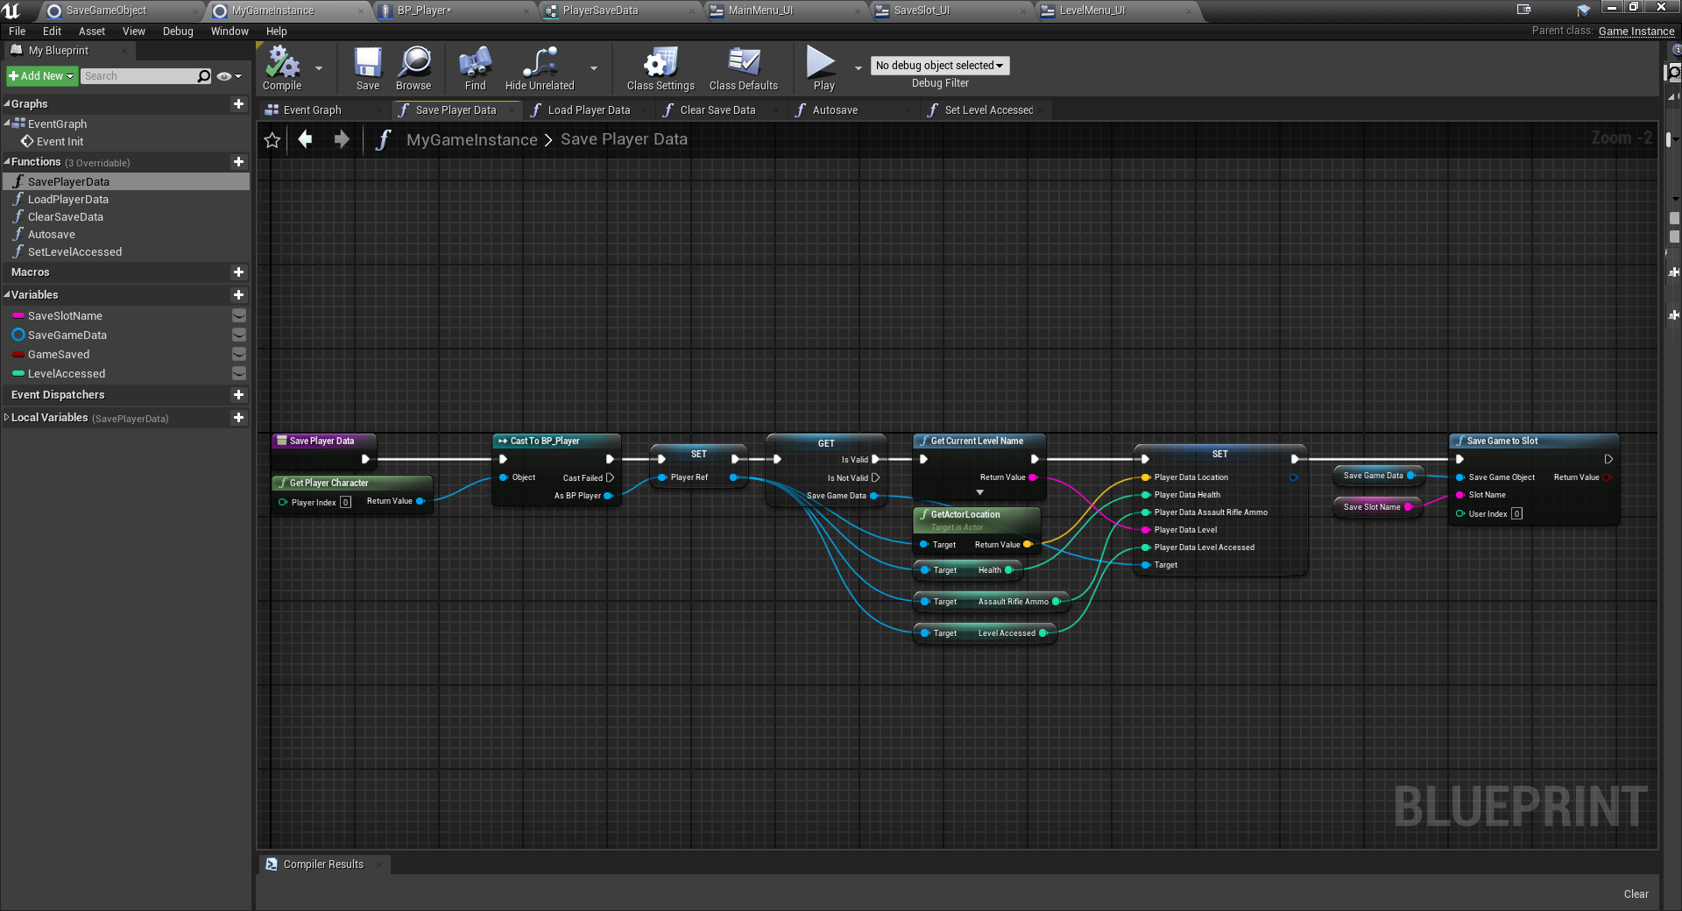

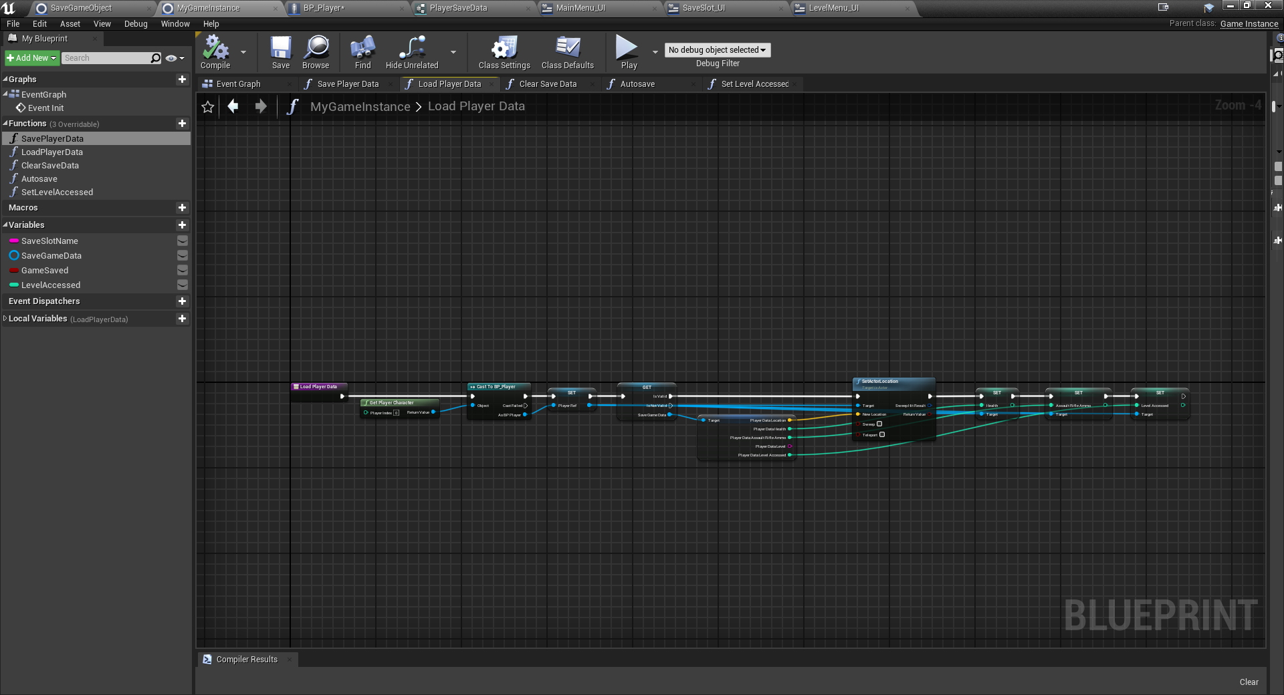

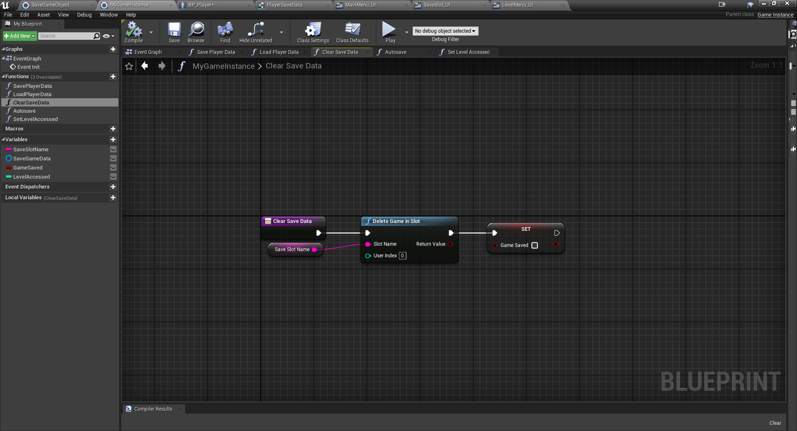

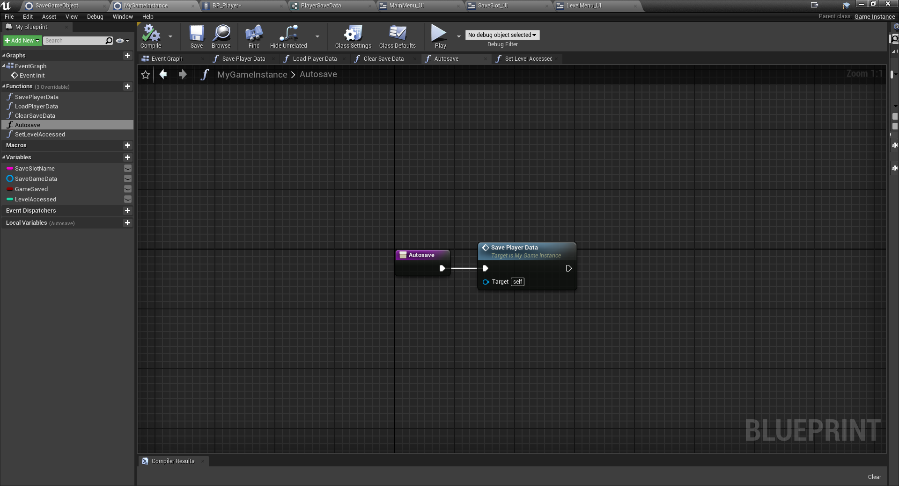

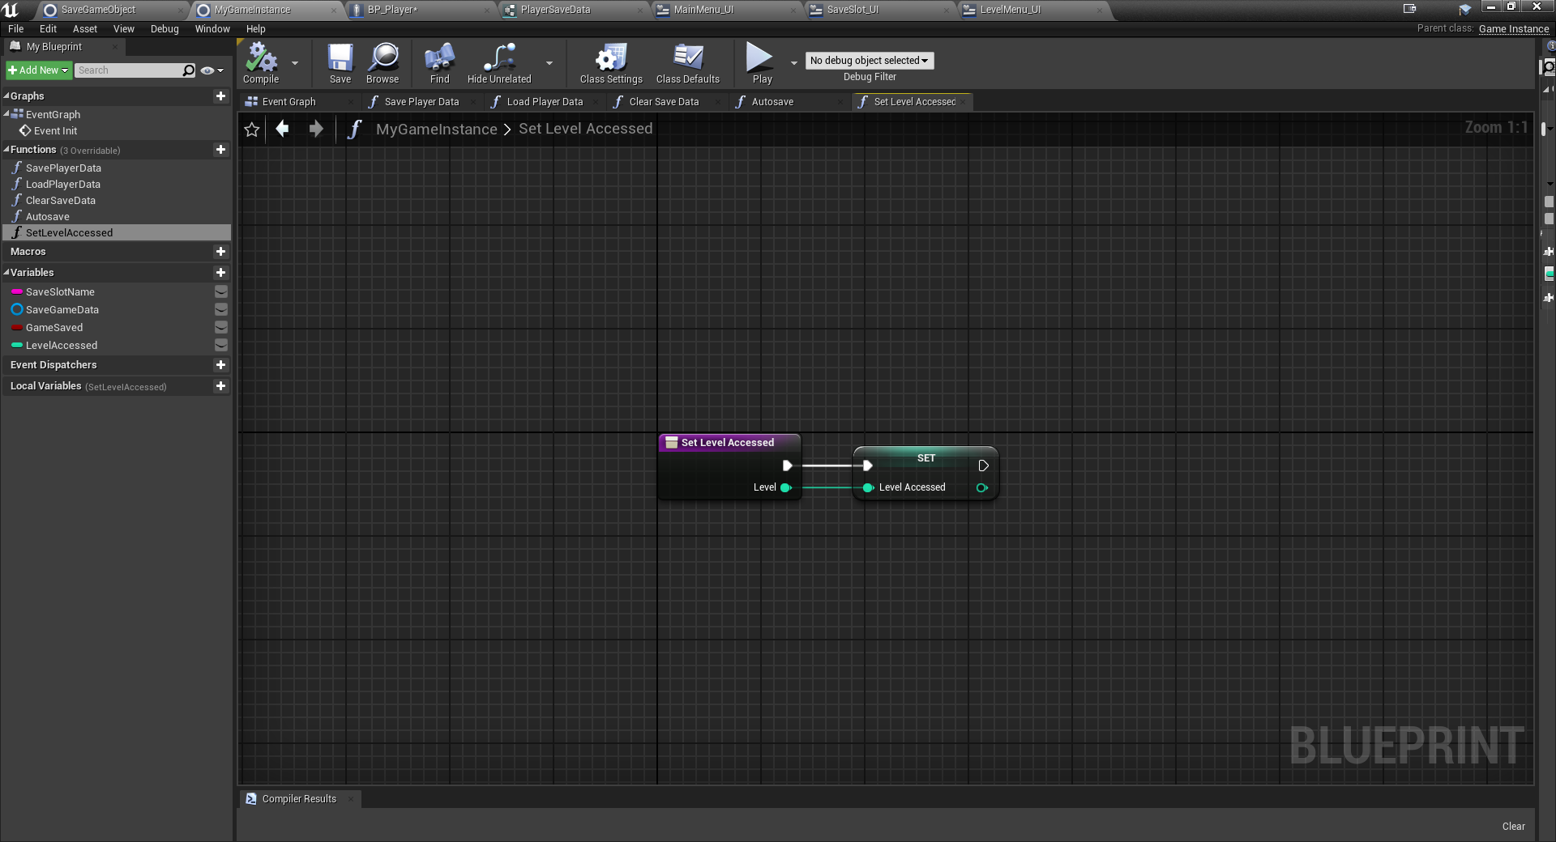

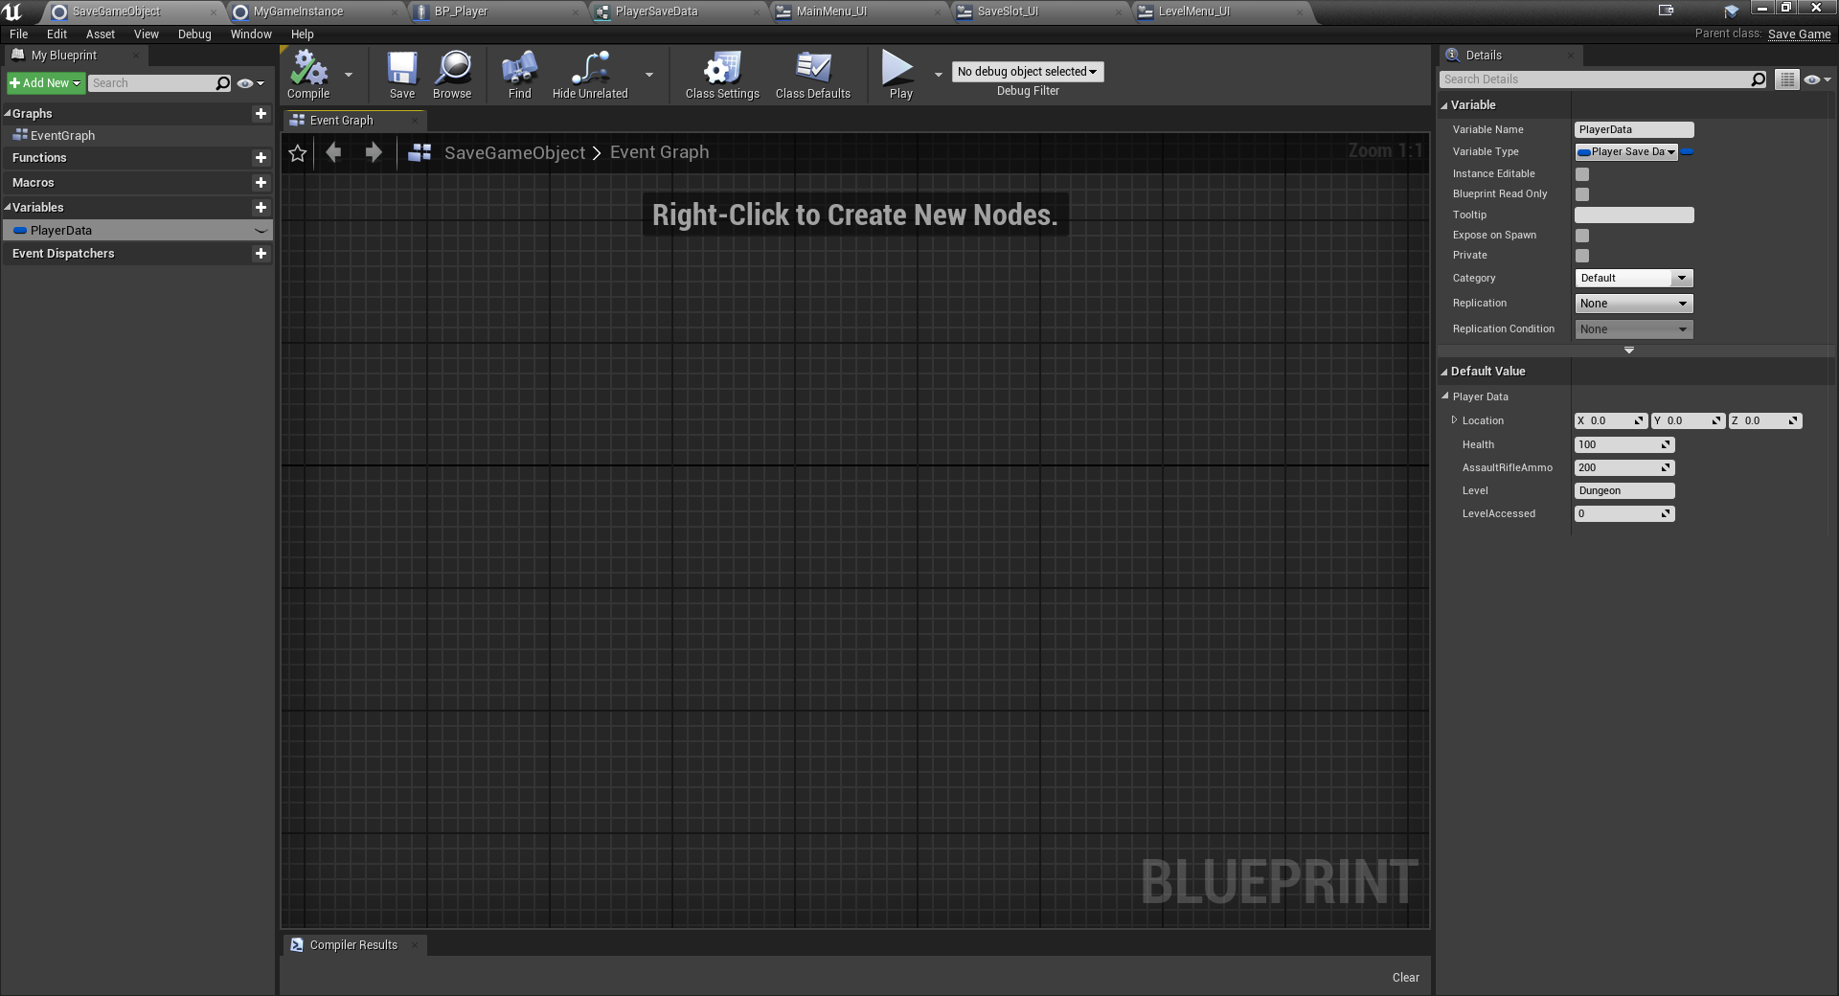

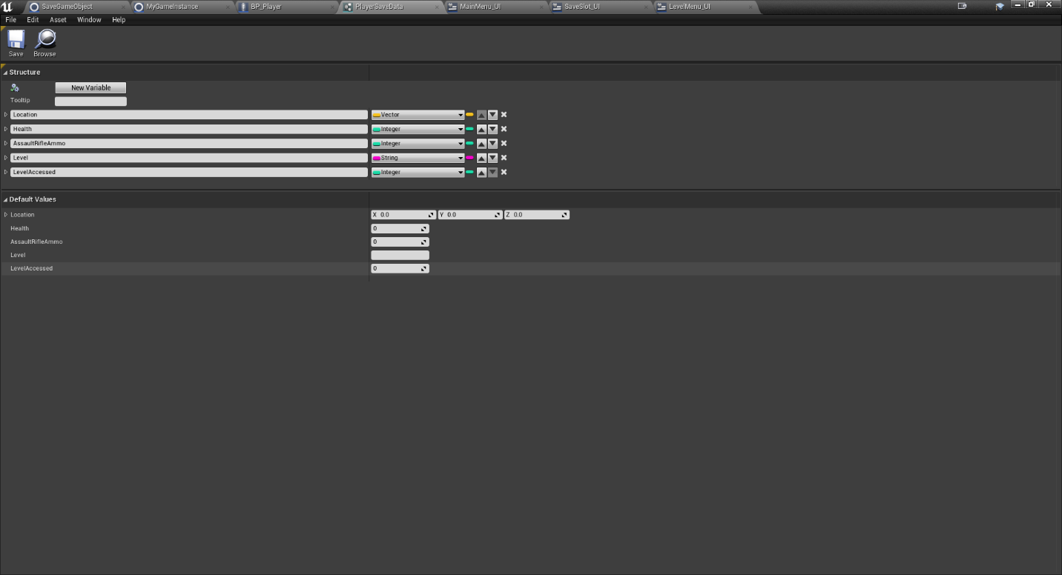

## Requirement: Intro Login Screen

